

# Simulating improvements on mining compressed air systems

B.M. Friedenstein 28354516

Dissertation submitted in fulfilment of the requirements for the degree *Magister* in Electrical and Electronic Engineering at the Potchefstroom Campus of the North-West University

Supervisor: Dr Johann van Rensburg

August, 2017

## Abstract

**Title:** Simulating improvements on mining compressed air systems

**Author:** B.M. Friedenstein

**Supervisor:** Dr Johann van Rensburg

**School:** North-West University Potchefstroom Campus

**Degree:** Masters in Electrical and Electronic Engineering

As operational costs of deep level mines increases and gold ore grades decrease, profitability in the gold mining sector is becoming a challenge. Electricity tariff increases have contributed to a rise in the cost of operating mines. Compressed air systems are utilised on mines as they provide safe, reliable power for various underground machines. Compressed air is also used for emergency oxygen in refuge bays.

Compressed air systems utilise a significant portion of a mine’s total energy. It has been shown that many deep level mine compressed air networks have inefficiencies. Improving the efficiency of these systems could result in a reduction of operational costs by reducing the energy required to produce compressed air. Additionally, an improvement in service delivery could be achieved.

Previous studies have shown the usefulness of simulations to develop improvements for deep level mining systems. However, these studies have not followed a structured methodology for developing compressed air simulation for deep level mines. Previous studies have also simplified compressed air models reducing the simulation precision and testable scenarios.

In this study a simulation methodology was therefore developed. Investigations into the compressed air systems are performed. A model is then developed in software to accurately recreate the system operation. Finally a proposed means of improvement is simulated, analysed and quantified in terms of improvements in energy savings and service delivery.

Two case studies were evaluated. For each case study a variety of scenarios were simulated. In case study A by reducing air used by refuge bays in simulation, a reduction of 1 MW E.E. would be achieved with addition to a significant improvement of 18 kPa to system pressure. Drop tests implemented on the case studies validated the simulation with a precision of 5%.

The study showed that simulation is a important tool for identification improvements in large compressed air systems. By utilising a structured methodology to develop detailed compressed air simulations, inefficiencies and operational improvements were identified.

**Keywords:** Mining, Energy, Compressed air, modelling, Simulation, operational im- provements

*Simulating improvements on mining compressed air systems* ii

## Acknowledgements

Contents

Abstract i

Acknowledgements iii

Abbreviations and nomenclature vi

List of figures and tables viii

1. Introduction and background 1

1.1 Preamble . . . . . . . . . . . . . . . . . . . . . . . . . . . . . . . . . . . . . 2

* 1. Background on deep level mining . . . . . . . . . . . . . . . . . . . . . . . . 2
  2. Compressed air systems in mining . . . . . . . . . . . . . . . . . . . . . . . . 5

1.4 Use of simulation in industry . . . . . . . . . . . . . . . . . . . . . . . . . . 9

* 1. Problem statement and objectives 10
  2. Dissertation overview 11

1. Overview of simulation and compressed air applications 12
   1. Introduction 13
   2. Review of compressed air energy interventions in industry 13
   3. Use of simulations to identify improvements in mining systems 18
   4. Use of simulation in compressed air system optimisation 22
   5. Conclusion 23
2. Developing a simulation methodology 24
   1. Introduction 25
   2. Investigate the system 26
   3. Develop and verify a simulation model 28
   4. Implementation of simulation method 36
   5. Conclusion 36
3. Results and validation 37
   1. Introduction 38
   2. Case study 1. Simulated improvements on mine A 38
   3. Case study 2: Simulated improvements on mine B 45
   4. Case study C: Periodic simulation analysis 53
   5. Potential benefit for SA mines 56
   6. Conclusion 57
4. Conclusion 58
   1. Conclusion 59
   2. Limits of this study 59
   3. Recommendations for future studies 59

Bibliography 59

Appendix I Network layout diagrams 64

Appendix II Simulation process Flow diagrams 66

Appendix III Model component verification tables 71

## Acronyms

CALDS Compressed Air Leakage Documentation System DCS Dynamic Compressor Selection

DSM Demand Side Management

E.E. Energy efficiency

p.a Per annum

P.C. Peak-clip

PGM Platinum group metal PI Proportional-Integral

PLC Programmable logic controller PTB Process Toolbox

SCADA Supervisory control and data acquisition SI International System of Units

SP Set-Point

STB Simulation Toolbox

THS Thermal-hydraulic simulation VFD Variable Frequency Drive VSD Variable Speed Drive

## Nomenclature

Celcius The SI measure for tempature *C*

kilopascals The international measure of pressure *kPa*

polytropic

coefficient The thermodynamic coeificient used when describing the heat transfer due to compression or expansion

---

Tonne The non-SI measure for 1000 kilograms *T*

Watt The SI measure of power *W*

# List of Figures

* 1. Electricity price increases between 2007 and 2017 compared to the inflation

rate in South Africa.. . . . . . . . . . . . . . . . . . . . . . . . . . . . . . . . 2

* 1. A layout showing the mining processes. . . . . . . . . . . . . . . . . . . . . . 3
  2. The energy consumption for each mining system. . . . . . . . . . . . . . . . 4
  3. An example of compressed air inlet in an underground refuge bay chamber of

a mine. . . . . . . . . . . . . . . . . . . . . . . . . . . . . . . . . . . . . . . . 6

* 1. A typical operation schedule of a deep level mine. . . . . . . . . . . . . . . . 7
  2. The estimated power loss vs leakage area. 15
  3. The Compressed air energy and flow consumed per T of ore produced. 16

2.3 . . . . . . . . . . . . . . . . . . . . . . . . . . . . . . . . . . . . . . . . . . . 19

2.4 Example of simulation error calculation. 21

* 1. Flow diagram of the methodology for this study. 25
  2. Model boundary selection examples. 28
  3. Average summer ambient air conditions at a South African gold mine. 30
  4. Estimating the characteristic curve of a compressor by fitting a quadratic function to points of operation. 31
  5. Integrating the compressor component into the simulation. 31
  6. Implementing flow demands and leaks into the simulation. 32
  7. Control components in Process Toolbox (PTB). 32
  8. Modelling the compressor control from a guide vain 33
  9. An example of a compressed air control valve. 33
  10. An example of two baseline periods, showing a changed compressor schedule. 35
  11. The periodic simulation process that was followed in this analysis. 36
  12. Simplified process flow chart of the compressed air network. 38
  13. Average power profile 39
  14. The simulated power compared to the actual measurement 41
  15. The simulated flow compared to the actual measurement 41

List of Figures

* 1. The simulated Pressure compared to the actual measurement 41
  2. Energy savings by reducing compressor set-points 42
  3. Power savings 43
  4. Actual power savings achieved on the system 44
  5. Basic layout of the compressed air network. 45
  6. Comparing the pressure response of simulation to the actual measured pressure 46
  7. Verification of the total (a) flow and (b) power of the system using the actual pressure profile. 47
  8. Verifying the Pressure response of the system given the pressure set points as inputs 48
  9. The Baseline system power compared to the system power when refuge bay leaks are reduced 49
  10. The Baseline system pressure compared to the system pressure when refuge

bay leaks are reduce. 49

* 1. Underground level layout. 50
  2. Flow reduction during blasting period for 105 level 50
  3. Comparing simulated flow interventions on 105L. 51
  4. Energy saving achieved by general peak time Station control 51
  5. The flow, pressure and power error percentages for daily periodic simulations

over a month. 53

* 1. Supply efficiency and Compressor 1’s average power output over the time of

the periodic analysis. 54

* 1. Comparison using alternative power source. 55
  2. Gold and PGM mines in South Africa 56

I.1 Underground level layout. 65

* 1. Mine A: Simulation process Flow diagrams 67
  2. Mine B: Baseline process Flow diagram. 68
  3. Mine B: Simulation process Flow diagrams for the refuge bay scenario. 69
  4. Mine B: Simulation process Flow diagram for the station isolation stope control. 70

# List of Tables

2.1 Simulation verification methods that were implemented in previous studies. . 21

* 1. Air pipe component model parameters. 29
  2. The input parameters for the after-cooling simulation model 34
  3. Data inputs and outputs for the Case study 1 simulation model 40
  4. Comparison of Mine A’s simulated scenarios 43
  5. Simulation inputs and outputs 46
  6. Comparison of the simulated scenarios 52
  7. Data inputs and outputs for the simulation 53
  8. Case study A: Model verification 72
  9. Case study B: Model verification 73

## CHAPTER 1

**Introduction and background**

‘*Quote.*’ - Somebody

## Preamble

This chapter firstly discusses background regarding deep level mining in South Africa. Next, the need to reduce costs of operation in the mining sector is examined. From this a focus in reducing energy consumption of compressed air systems is developed. Next, background on compressed air operation and energy interventions are discussed. Simulations and their value in industry is discussed leading to a problem statement and objectives of the study. Finally, an overview for the dissertation is provided.

## Background on deep level mining

### Mining profitability

Various technical, economic, social and operational challenges are posing a risk to the profitability of the South African mining sector. One of the challenges the sector faces is a rise in the cost of operation [2].

A considerable factor that is contributing to the rise of operational costs in South African gold mines has been the increase in electricity costs. As shown in fig. 1.1, the general cost of electricity has increased at a rate greater than inflation since 2008 [3].

40

35

30

25

20

15

10

5

0

2008

% increase

31.3

27.5

24.8

25.8

16.0

9.35

8.0

5.3

3.37

2010

8.0

5.32

2014

8.0

6.04

6.41

5.71

2012

Year

5.18

8.0

7.07

8.0

6.2

2016

Eskom tariff increases (%) Inflation rate (%)

Figure 1.1: Electricity price increases between 2007 and 2017 [3] compared to the inflation rate in South Africa.1

In addition to rising electricity costs, gold ore grades of South African mines have fallen

1 inflation.eu, ”Historic inflation South Africa.” [Online] [http://www.inflation.eu/inflation-rates/](http://www.inflation.eu/inflation-rates/south-africa/historic-inflation/cpi-inflation-south-africa.aspx) [south-africa/historic-inflation/cpi-inflation-south-africa.aspx](http://www.inflation.eu/inflation-rates/south-africa/historic-inflation/cpi-inflation-south-africa.aspx), [Accessed 25 March 2017].

substantially over the last few decades [4]. As ore grades decline, the energy utilised per unit of metal increases exponentially [5]. Therefore mines require significantly more energy per unit of metal produced. This combination of tariff increases and increased energy usage per unit have led to significant rises in mining operation costs.

### Process of a deep level mine

South Africa’s mines are some of the deepest in the world Some mine shafts are reaching depths deeper than 4000*m* below the surface [6]. The process of extracting ore at this depth is dependent on the essential services, mainly cooling and ventilation, pumping, compressed air and hoisting, as shown in fig. 1.2.

Cooling and ventilation system are required to maintain a safe working temperature un- derground. Pumping is critical to remove service and fissure water, preventing flooding. Compressed air is needed to safely power underground drills and machines. Finally, hoisting systems are used to bring the ore to the surface and to transport mine workers in the mine.

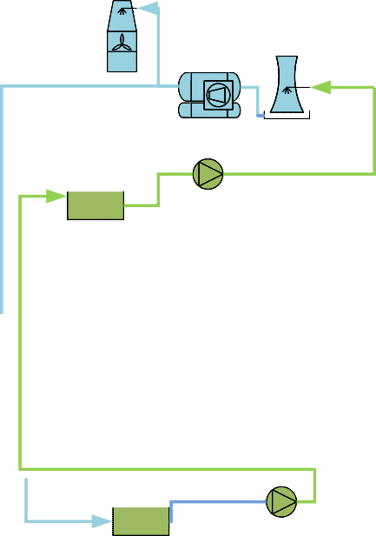

BAC Tower

Processing plant

Fridge Plant

Compressors

PCT

Ventilation Fan

Surface

V-101

Level 1

Pump

Dam

Level 2

...

...

...

Pumping

Processing plant Hoisting Compressed air

Ventilation and cooling

Level N-2

Level N-1

Level N

Shaft

Dam

Pump

Figure 1.2: A layout showing the mining processes.

#### Energy usage of mining services

The mining industry uses extensive amounts of energy. In South Africa, the industry utilizes approximately 15% of the national electricity supplier’s yearly output, of which, gold and platinum mines use 80%.[7]

fig. 1.3 shows the division of energy within the mining industry. The chart shows that compressed air systems utilizes the most energy within a mining industry. It is reasoned that energy can be most effectively reduced through the implementation of energy interventions on compressed air systems.

25

20

15

10

5

0

Compressed Mining

air processes

Ventilation Buildings Processing

and cooling

Pumping

and hostels

plant

Hoisting

Other

% of total energy consumption

Figure 1.3: The energy consumption for each mining system [8].

## Compressed air systems in mining

### Compressed air in operation

Largely due to their reliability, versatilely and ease of use, the South African mining industry has installed extensive compressed air networks. These systems can have compressors with capacities of up to 15 MegaWatt (*MW* ) [9]. *** compress process inefficient ** However, the supply of compressed air is a highly energy demanding and costly process [10]. The energy used for compressed air production contributes to between 9% and 20% of the total mining energy consumption [7],[11].

Large compressed air systems are likely inefficient. Internationally, the expected energy savings potential of a large compressed air network is 15% [12]. Marais [13] showed that energy savings of up to 30% and 40% can be attained through various interventions.

#### Pneumatic rock drills

Drilling is mainly performed in the production areas or stopes of a mine. Drill machines are used to drill holes into the rock face. Once the holes have been drilled, explosives are then installed to break up the rock [14].

Compressed air is used to power pneumatic rock drills within a mine. Pneumatic rock drills run at an efficiency of 2%. This is low when compared to alternative rock drills such as electric, oil electro-hydraulic and hydro-powered drills that run at an efficiency of between 20-31% [15], [16].

#### Refuge bays

Refuge bays are installed underground in deep level mines to provide safety to miners in the event of an emergency. To satisfy the safety criteria, most mines will utilize compressed air to deliver cool air to the chamber [17]. fig. 1.4 shows an example of a compressed air inlet at an underground refuge bay. A muffler is installed to the end of the inlet air pipe to reduce noise.

The provision of 1.42 *l/s* of air per person at a pressure between 200 and 300 kilopascals is required to provide oxygen and prevent any poisonousness gas entering the refuge [17].

Airflow in the refuge bays can be controlled with a manual valve within the chamber. Often, this valve is often misused by mine workers who open the valves fully in order to cool the

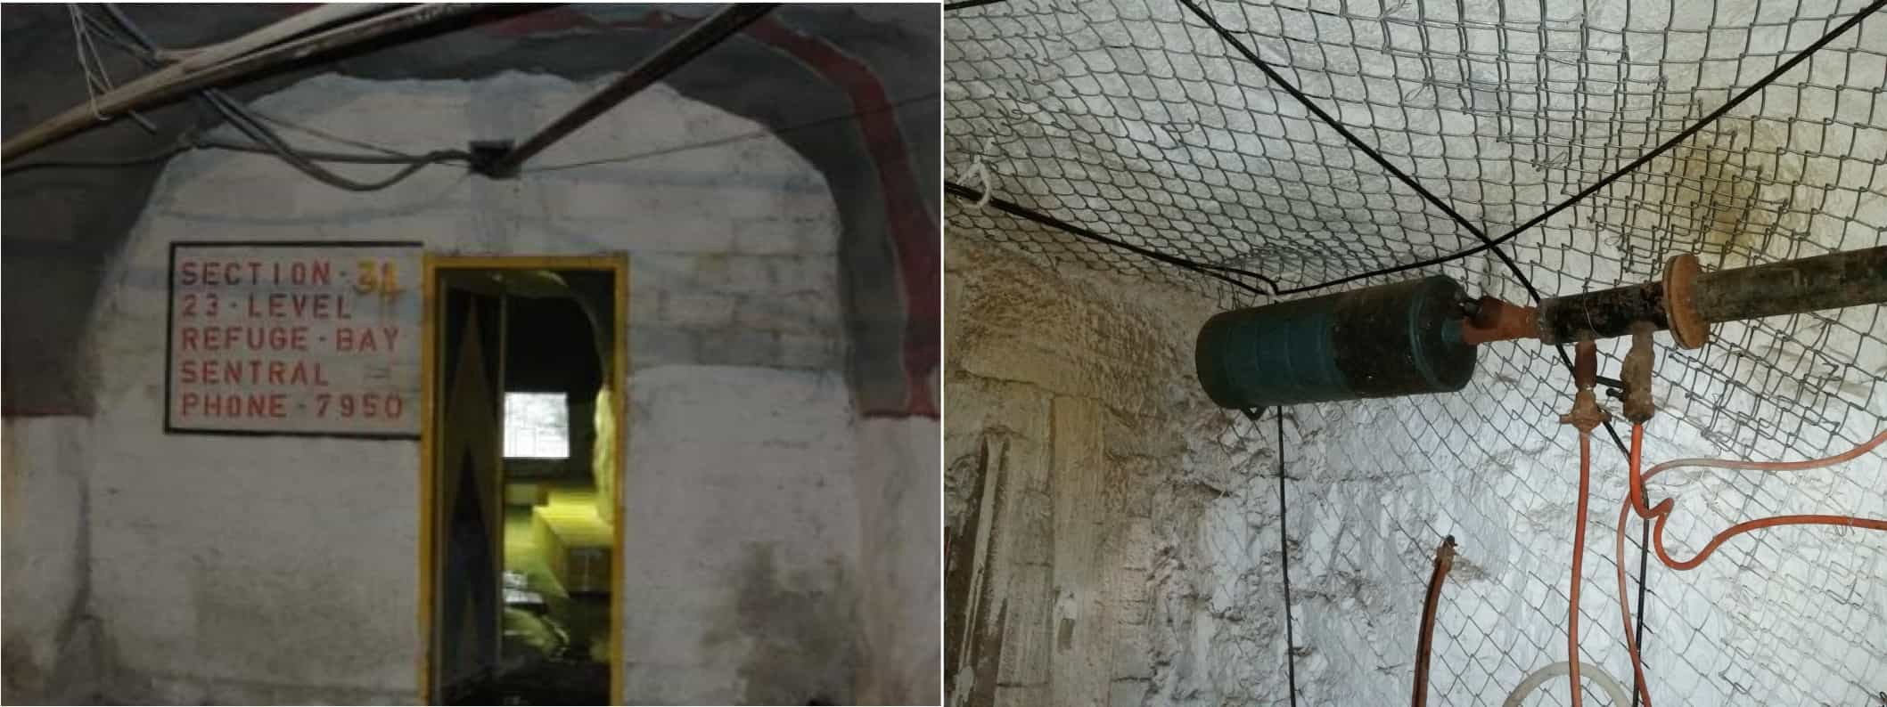

Figure 1.4: An example of compressed air inlet in an underground refuge bay chamber of a mine.

bay through decompression of the air.[CitationNeeded]

#### Processing plants

Processing plants are constructed near gold and mines. They are used when extracting metal from the ore that is obtained from the mining operation. These plants use compressed air for various systems, processes and equipment.

To save costs, processing plants often share compressed air network with mine [9]. The plants use relatively low amounts of air compared to mines, however plant processes have pressure requirements that differ from the rest of the air network. If the plant is not isolated from the mine air network, compressed air optimizations on the mine can be complicated.

#### Other compressed air uses

Due to the availability underground, compressed air is utilised for a number of other applications. These usages include, pneumatic loaders or rock shovels, pneumatic cylinders, dam sediment agitation, cooling and ventilation and many other applications. This vast variety of of applications also leads to misuse of compressed air this leads to inefficient operation.

#### Operation schedule

On a typical mine, various operations will take place at different times of the day. Depending on the activity taking place, many mines will control the pressure to meet the requirements [18],[9]. fig. 1.5 shows the schedule and pressure requirement on a typical deep level mine.

As shown in the figure, the pressure requirement changes depending on the activity taking

place. The drilling shift typically has the highest pressure requirement whilst blasting shift requires the lowest. Schedules and operation philosophies can differ between mines. Different operational schedules require alternative pressure requirement profiles.

Drilling

Blasting

560

540

520

500

480

460

440

420

400

Time of day Pressure requirement (kPa)

Pressure (kPa)

Sweeping and

cleaning

Workers travel to working areas

Explosive charge up

Sweeping and

cleaning

Figure 1.5: The typical operation schedule of a deep level mine [18].

00:00

01:00

02:00

03:00

04:00

05:00

06:00

07:00

08:00

09:00

10:00

11:00

12:00

13:00

14:00

15:00

16:00

17:00

18:00

19:00

20:00

21:00

22:00

23:00

### Characteristic inefficiencies of compressed air systems

Compressed air distribution networks in the mining industry consist of multiple compressors and working areas up to eight kilometres away from the source [9]. Due to their size and complexity, these systems are prone to large energy losses.

Compressed air leakage accounts for as much as 35% of the energy losses of a compressed air network [19]. Other systemic losses include, faulty valves, pipe diameter fluctuations, obstructed air compressor intake filters and inefficient compressors.

### Instrumentation and measurements

For large industrial systems, thorough instrumentation is necessary in order to monitor performance and equipment condition throughout the system. In a mining compressed air network, instrumentation is installed to monitor flows, pressures, temperatures ,etc. Electrical instrumentation is also installed for sensing currents, power factors, voltages and power. On control valves, input/output pressures, flows and valve position are usually measured with instrumentation.

A Supervisory control and data acquisition (SCADA) system is used to monitor and control processes throughout the mine from a control room. The SCADA centralises instrumentation

data from Programmable logic controllers (PLCs) throughout the mine. The SCADA can also be used to control machines and instrumentation by sending control signals to the relevant PLC. Communication to the underground PLCs is achieved using a substantial fibre optic network.[20]

### Inefficiency identification methods

Leakage and inefficiency detection strategies is not often pursued in the South African mining industry [16]. Many mines do however perform leak inspections either internally or by a outside company. In these inspections, an ultrasonic detector is used to locate the leak. Alternatively, some mines employ the “walk and listen” method to identify leaks from the audible sound that it produces [16]. Once the inspection is completed, the findings, including the locations and estimated costs of all identified leaks, are reported.

### Compressed air savings strategies

Strategies to reduce energy on compressed air systems can be summarised as follows [21]:

* + - * Reducing leaks.
      * Reducing demand.
      * Reducing unauthorised usage.
      * Increasing supply efficiency.
      * Optimising supply.

Often a combination of energy strategies will lead to the most savings [9]. Specific energy saving measures that have successfully reduced energy on mine compressed air systems will be discussed in Chapter 2.

## Use of simulation in industry

### Background in industrial simulation

Continuous improvements in computing hardware has led to major advancement in software technology. Consequently, the use of computational simulation has become an increasingly valuable tool for many industries.[22]

In *Handbook of simulation: principles, methodology, advances, applications, and practice*, the advantages of the use of simulation in industry are discussed as follows [23]:

* + - * The ability to test new policies, operating procedures and methods without causing a disruption to the actual system.
      * The means to identify problems in complex systems by gathering insight in the interac- tions within the system.
      * The facility to compress or expand time to investigate phenomena thoroughly.
      * The capability to determine the limits and constraints within a system.
      * The potential to build consensus with regard to proposed designs or modifications.

### Simulation usage in mining

Simulation has been used to test and identify energy and operational improvements in mining systems. However, existing tools require too much data to model the systems accurately [CitationNeeded]. New tools such the Simulation Toolbox (STB) software, have made it possible to develop accurate, detailed simulations for mining systems. This allows for testing of more complex intervention scenarios, leading to more improvements for the mine than could be previously obtained.

### Comparison of available simulation tools

philip phd [1]

Peach [24]

## Problem statement and objectives

### Problem statement

Rising costs and falling ore grades are driving in the mining industry to reduce operational inefficiencies. Large energy savings can be made in Compressed air systems in the mining industry. However manual testing of interventions can be cumbersome.

Computer modelling and simulation of compressed air systems can be used to quantify and priorities operational interventions that improve efficiency. These interventions can be evaluated with minimal risk. However, simulations have not been utilized to their full potential in the mining industry. With new tools that allow for more detailed simulation models of mining systems could allow for of identification of more effective energy savings measures for mines.

### Research objectives

The main objective of this dissertation is to obtain energy savings through the identification of operational improvements in mining compressed air systems. A simulation process to will be developed to achieve this goal.

## 1.6 Dissertation overview

Describe (in approximately one sentence each) the contents of each of the dissertation chapters. No results here.

## CHAPTER 2

**Overview of simulation and compressed air**

**applications**

‘*Quote.*’ - Somebody

## Introduction

## Review of compressed air energy interventions in industry

### Preamble

Compressed air improvement can be obtained through intervention in either the supply or demand of compressed air [18]. Improvements in supply interventions are achieved by increasing the efficiency of compressed air supply. Examples of this type of intervention include Dynamic Compressor Selection (DCS), compressor maintenance, etc.

Due to the size of mining compressed air networks, there is often a larger scope for improvement in air demand. Improving the demand is achieved by optimising air flow consumers, reducing leaks, etc.

This section will review compressed air supply and demand interventions that have improved energy or operation efficiency the mining industry. From the, successes and shortcomings in studies will be discussed and analysed with regard to this study.

### Strategies to improve compressed air supply

#### Compressor efficiency improvements Optimising compressor control

Compressors types and numbers can differ widely from mining compressed air systems. Compressor selection is crucial in these systems to match the correct compressors with the requirements of the system [25].

In a study by Booysen *et al* [26] on optimising compressor control, [26] found that many mines control compressors using fixed target pressure points that are much higher that required. In one system, compressors were set to a target 650 kilopascals to ensure pressure underground did not fall below 500 kilopascals. Using high pressure set-points can lead to excessive wasteful blow-off flow when the pressure exceeds a maximum points.

Booysen [27] showed that through dynamic pressure setpoint control, matching the supply pressure with the demand, and optimal compressor selection, energy savings can be achieved.

In a case study, an average power reduction of 1.07 MW was achieved. The lead to an estimated energy cost saving of R3M.

Optimising control of compressors to match the demand of the system can be complicated. Variable Speed Drives (VSDs) and guide vain are used to control the capacity of the system. More effective power reductions can be achieved through the use of VSD control. Running compressors at part load reduces efficiency. From literature it shown electric motors will typical use 60-80% of there rated power when running at *<*50% load [28].

#### Reconfiguring compressed air networks

A number of old mining compressed air systems have not been adequately maintained and improved. Often they cannot sufficiently supply air to meet the demand or air is provided from non optimal sources. In a study by Bredenkamp [29], reconfiguring of the air network was investigated to improve these systems.

In the study, Bredenkamp investigated interconnecting the compressed air systems of two mining shafts and relocating of a compressor. This strategy lead to an average power reduction of 1.7 MW and an estimated annual energy cost saving of R8.9M at the time.

*** *Discussion of Bredenkamp* shortcomings and successes ***

### Strategies to reduce compressed air demand

As illustrated in fig. 1.5 - Reducing leaks

* Marais PhD
* Snyman - investigated various Compressed air demand reduction and efficiency optimisations [21].

#### Leakage detection

Air leaks are a major inefficiency in mining compressed air systems. Improving leaks is relatively easier method to reduce air demand and improve the efficiency of the system [30]. Air leaks occur as a result of open pipes, fissure and breaks. Losses depend on the size of the leak. fig. 2.1 shows the estimated power losses vs leakage area.

***Fix this booysen 1.20 *** Air is often not easily detected through visual methods. In industry, a number of techniques are employed to detect air leaks. Pascoe [31] and van Tonder [16] summarised these strategies as follows:

|  |  |  |  |  |  |  |
| --- | --- | --- | --- | --- | --- | --- |
|  |  |  |  |  |  |  |
|  |  |  |  |  |  |  |
|  |  |  |  |  |  |  |
|  |  |  |  |  |  |  |
|  |  |  |  |  |  |  |
|  |  |  |  |  |  |  |
|  |  |  |  |  |  |  |
|  |  |  |  |  |  |  |

Figure 2.1: The estimated power loss vs leakage area [30].

8000

7000

6000

5000

4000

3000

2000

1000

0

0

5000

10000

15000

20000

25000

30000

Leak size (*mm*2)

Power loss (kW)

* + Audible detection (Walk and report)
  + Ultrasonic detection
  + Detection through intelligent systems
  + Pigging
  + soap water and dyes

These methods can be time and resource intensive and many mines do not actively employ dedicated leakage detection repair teams. Marais *et al* [32] investigated streamlining the leakage detection and repair process to increase energy savings through the use of Compressed Air Leakage Documentation System (CALDS). The CALDS system was developed to allow centralised mobile leakage reporting. Usage of the system resulted in increased leak detection rate with one mine reporting 24 leaks in a single month. It was noted in the study that there difficulty quantifying the actual energy savings of the leakage repairs due to other intervention occurring simultaneously.

#### Underground control valves optimisation

Many mines utilise automated valves at critical locations or levels in the compressed air network. These valves control the pressure, restricting airflow from that point in the air network. Restricting airflow reduces losses resultant from network inefficiencies and leaks.

Kleingeld and Marais [33] found that optimising control valve control on mining levels can conservatively lead to between 20% on mines where no control valves are installed. For systems that already have some form of network control, between 10 and 15% savings can conservatively be achieved.

From literature, the advantage of control valve optimisation is the significant savings that can be achieved with relatively short set-up up time. Savings can be achieved incrementally with each control valve installation. Studies did not look at accurate estimations of savings or the shaft pressure improvements that result from control valve optimisation.

#### Improving pneumatic rock drill efficiency

Pneumatic rock drills are on of the largest air consumers in a mine. However Pneumatic drilling systems are convert energy very inefficiently. Replacing pneumatic drills with more efficient alternatives such as hydraulic or pneumatic drills would lead to large energy savings [31]**. Alternatively improving the efficiency or pneumatic drilling can have a significant energy impact on the system, without the cost and safety concerns of alternative drilling technologies.

In a study by Bester *et al.* [34] looking at the effect of compressed air pressure on energy demand. Bester showed that between 2002 and 2013 compressed air and energy consumption per tonne of ore produced had steadily increased. This is illustrated in fig. 2.2. The increase of air consumption per Tonne was a result of reduced air pressure at the mining areas. This causes the drilling rate to drop leading to higher air consumption. Pressure measurements as low as 300 kilopascals were recorded in these areas. Before 2002 the drilling pressure at the mining section (stopes), was maintained above 500 kilopascals at most mines.

40

35

30

25

20

15

10

5

0

2002

2004

2006

2008

Year

2010

2012

400

350

300

250

200

150

100

50

0

2014

Energy per Ton (kWh/t)

Volume per Ton (*m*3/t)

*kWh/t*

*m*3*/t*

|  |  |  |  |  |  |
| --- | --- | --- | --- | --- | --- |
|  |  |  |  |  |  |
|  |  |  |  |  |  |
|  |  |  |  |  |  |
|  |  |  |  |  |  |
|  |  |  |  |  |  |
|  |  |  |  |  |  |
|  |  |  |  |  |  |
|  |  |  |  |  |  |

Figure 2.2: The Compressed air energy and flow consumed per T of ore produced. Adopted from Bester *et al.* [34].

From literature, it is shown that lowering the pressure reduces the efficiency and drill rate of rock drilling, leading to higher air consumption. Interventions that reduce systemic air losses or optimise supply can increase the pressure operating pressure. Increased pressure, during

the drilling shift, may add more value than the energy cost savings that can be achieved at a lower pressure.

### Summary

## Use of simulations to identify improvements in mining systems

* + 1. **Preamble**

The value of simulation in the mining industry has been shown through its use in Demand Side Management (DSM) initiatives. Simulation has been used to identify savings strategies for water reticulation cooling, compressed air and ventilation. This section will summarise the the work that has been done in industry. From this the successes and shortcomings of previous work will be discussed.

### Estimating techniques used for energy savings on mining systems

Estimation of energy savings has been used in literature to obtain the potential energy impact that can be achieved for a system. Before new tools allowed for quick development of simplified simulation models, estimation techniques were frequently used to determine the feasibility of energy interventions on mining systems. The problem with an estimation approach is that they typically rely on simplified models with high resultant error.

* Snyman estimated improvements using historical data.[21]
* Marais estimation through simplified estimation, simulation [9],[13].

#### Benchmark modelling

Cilliers [35] developed “best practice models” using the Corrected Ordinary Least Square (COLS) benchmarking method. These models provide an energy benchmark that can be used to identify the scope for energy improvements on a system. An example of a benchmark model for a mining compressed air system is shown in **??**. The model shows that energy required is dependent on the quantity of ore mined aswell as the the depth of the mine. [35] also developed benchmark models for mine cooling, water reticulation and ventilation systems.

### Value of simulation in mining DSM

Van Niekerk [36],[37] investigated the value of simulation models in mine DSM projects. Van Niekerk developed simulation models for compressed air and water reticulation systems using KYPipes’s gas simulation engine.

Figure 2.3:



120

140

100

1

80

2

3

4

0 20

4060

10

8

6

4

2

0

160

0

*Ecomp* = 1*.*51 *· Z* + 33*.*36 *· T −* 1930*.*21

Benchmark energy (GWhr)

#### Mine cooling systems

Simulation has been used in studies as a tool to improve mine cooling. Holman [38] investigated improvements to mine cooling systems that improve performance and efficiency. In the study [38] used simplified PTB simulation models to investigate cooling interventions.

The scenario Holman simulated showed potential average power reduction of 136 kW which would lead to an annual energy cost saving of R0.55M. The study could be improved by increasing accuracy of the simulation. Power difference of as high as 31% between the simulation and actual were observed for some time periods.

#### Mine de-watering systems Mine compressed air systems

* + 1. **Simulation procedures**
* Philip - Kriel masters

#### Periodic simulation

* + 1. **Simulation model verification strategies**

From literature, methods of verifying simulation were analysed. Most studies utilised a comparison calculation strategy to calculate a model accuracy or error. Two calculation methods identified were *Average difference method* and *average percentage difference*.

#### Average difference method

The average difference method looks at the sum for a simulated output for all time-steps in the period. This same is done for the actual system value. The error % is then calculated as shown in eq. (2.1)

*N*

( *An* \

*N* ( *Mn* \

*n*

*Err*% =

*N − n N*

*N* ( *An* \

*n*

(2.1)

*N*

Where:

*A* Actual system parameter

1. Model parameter

*n* sample

1. Number of samples in simulation period

#### Relative error method

The relative error method follows a similar calculation as in the Average difference method. However, as shown in eq. (2.2), the error is calculated for each sample in the period is calculated, the average of the error is then calculated.

*An* *− Mn*

Where: Yu-jie Xu [39]

*Err*% =

*N*

*n*

*A*

*n*

*N*

(2.2)

*A* Actual system parameter

1. Model parameter

*n* sample

1. Number of samples in simulation period

The difference between the two verification strategies is best shown using an example. Figure fig. 2.4 Shows a comparison between a simulation model’s output power and the actual power of the system over a 24 hour period. In a study by [1], the average % difference method, eq. (2.1), was used to calculate the accuracy of a simulation model. The average of the two power profiles were similar, leading to a calculated error of 1.17%. However, the Relative error method, eq. (2.2), applied to the same data the results in a error of 15.2%.

10

9

8

7

6

5

4

3

2

1

0

Power (*MW* )

%*error*

70

60

50

40

30

20

10

0

02:00 04:00 06:00 08:00 10:00 12:00 14:00 16:00 18:00 20:00 22:00 00:00

Time of Day

Actual power Simulated power

Error

Average Actual

Average Simulation

Figure 2.4: Example of simulation error calculation. Adapted from Mar`e [1]

#### Verification in previous studies

Previous studies used verified there simulations through different methods and varying degrees of precision.

|  |  |  |  |
| --- | --- | --- | --- |
| Study | Year | Verification method | Accepted margin |
| Holman [38] | 2014 | Average % difference | Not specified |
| van Niekerk [37] | 1900 | Average % difference | 5% difference |
| Kriel [9] | 1900 | Average % difference | 5% difference |
| Pascoe [31] | 1900 | Average % difference | 5% difference |
| Mare [1] | 1900 | Average % difference | 5% difference |
| Marius [9] | 1900 | Average % difference | 5% difference |
| Snyman [21] | 1900 | Average % difference | 5% difference |
| Yu-jie-Xu [39] | 1900 | relative % error | 5% error |
| Peach [24] | 2016 | Average % difference | 5% relative error |

Table 2.1: Simulation verification methods that were implemented in previous studies.

## 2.4 Use of simulation in compressed air system optimi- sation

#### Simulations on compressed air systems

* Pascoe
* van Tonder
* kriel
* Mare
* De Coning
* simulations to investigate the opportunity to optimise the control strategy of a compressed air network by rescheduling the compressors.

**2.4.1 Summary**

## 2.5 Conclusion

**CHAPTER 3**

**Developing a simulation methodology**

‘*Great Design is iteration of good design.*’ - Dr M. Cobanli

## Introduction

This chapter details the implementation methodology of simulations to optimize mining compressed air systems. The methodology discussed in this chapter will utilize insights from previous studies. Improving on shortcomings discussed in section 2.4.1.

Implementation of a simulation is divided into three steps as shown in the flow diagram, fig. 3.1. Firstly, an investigation on the specific air network to is performed. The data acquired from this investigation is then utilized to develop and verify a simulation model. In the final step, scenarios are tested using simulations and the results are quantified and prioritised. After the process has been reviewed, a simulation report is then produced and passed to the mine.

Investigation

System modelling

Verification

Simulations

Data analysis

Feedback

Review process

Prioritise

operational interventions

Report results

to the mine

Figure 3.1: Flow diagram of the methodology for this study.

## Investigate the system

### Preamble

Developing a detailed simulation model of a compressed air network requires thorough comprehension of the inner workings of the system. This section will discuss the investigations needed to obtain the required understanding.

### Acquire data

The first step of the system investigation is to acquire the data and understanding that will be required to model compressed air system’s function. This will require access to mine resources such as data storage systems, instrumentation, and communication with relevant engineers and personnel.

Comprehensive and up to date layouts illustrate a compressed air network’s unique set- up, scale and location of instrumentation. More detailed layouts can provide per-level air consumption breakdowns of the network, locations of refuge bays, mining cross-sections and identified inefficiencies. This is vital to understand the operation and identify what data parameters will be required for the model.

A baseline period that best represents the typical operation of the mine. Additionally, availability of data should be considered. The length of the baseline period is selected based on the scenarios that are to be tested, this can be changed later. For calibrating a compressed air system a 24 hours period of normal operation is usually sufficient. A longer period may be needed to verify the model. Next data

### Investigate mining schedules

A critical aspect to developing an accurate model of a mining compressed air system is apprehension of the operational philosophy of the mine. The schedule for operations such as drilling, blasting or cleaning can have a major impact on compressed air requirements at different times of the day. By utilizing the operational schedule, simulation scenarios can be optimized for the air requirements throughout the day.

### Verify data accuracy

Data verification is the process where data is evaluated to ensure accuracy. It is important to verify data that is used for model development as an accurate representation of the operation

of a system can only be achieved utilising data of high quality [40]. The factors that influence a data-set’s quality, accuracy and integrity summarised as follows:

* + - * Conversion of measurement value [41]
      * Storage and collection of the system [42],[43]
      * Traceability of measurement sources [43]
      * Measurement equipment accuracy and malfunctions [40]
      * Data abnormalities [40]

Therefore a data verification methodology is utilised to ensure datasets are of high quality.

### Resolve unavailable data

Parameters that are required to develop the simulation model, such as flows, pressures, may not be actively logged by mine systems. To obtain this data it is necessary to investigate alternative sources. At points where instrumentation is absent, estimations can be made from assumptions made using instrumentation on the network or spot inspections.

Air network specifications such as piping sizes, technical layouts, major leak locations or specifications is often outdated or not recorded. Critical data should be obtained through audits and inspections of the system. If manual inspection is not possible, estimations should be made using the available data or approximation techniques discussed in literature.

### Summary

## Develop and verify a simulation model

* + 1. **Preamble**

Compressed air networks are comprised of components such as compressors, valves, pipes, etc. This section will discuss the development, calibration and verification of component models that make up a compressed air simulation.

### Select the system boundaries and simulation parameters

The simulation boundaries determine the detail that the system is modelled. For a simple compressed air model, the boundaries can be set around the compressor house. This model would then only include the compressor components, inlet and outlet airflows. Alternatively a more complex model can be developed by choosing boundaries to include more aspects of the system such as mining levels, processing plants etc.

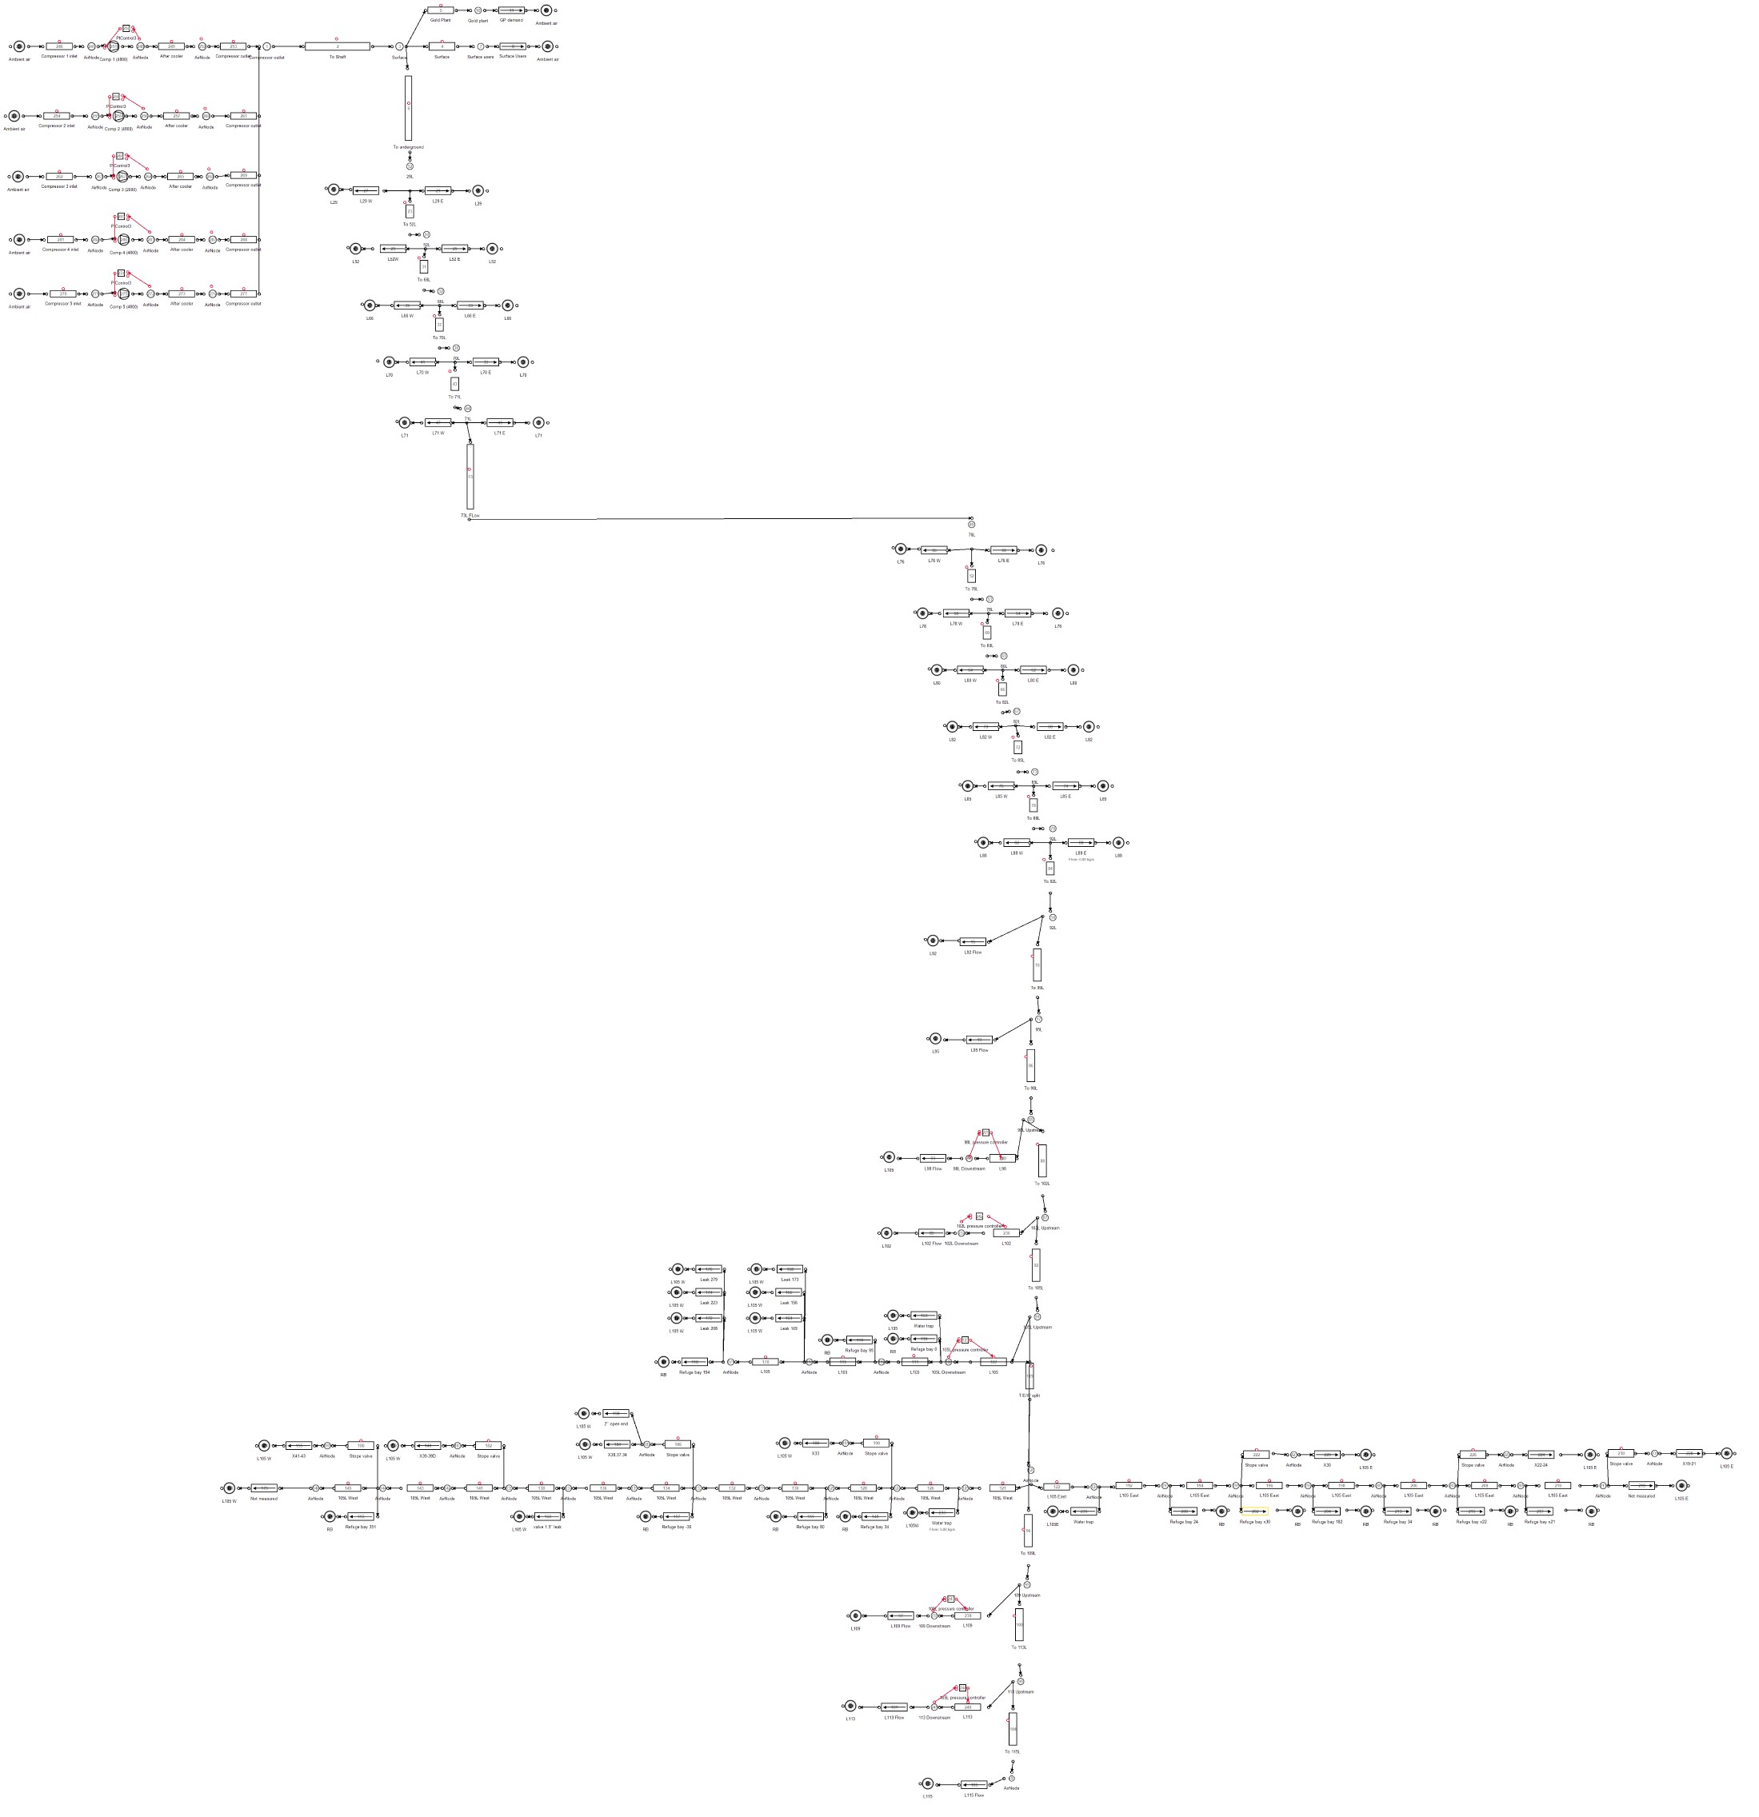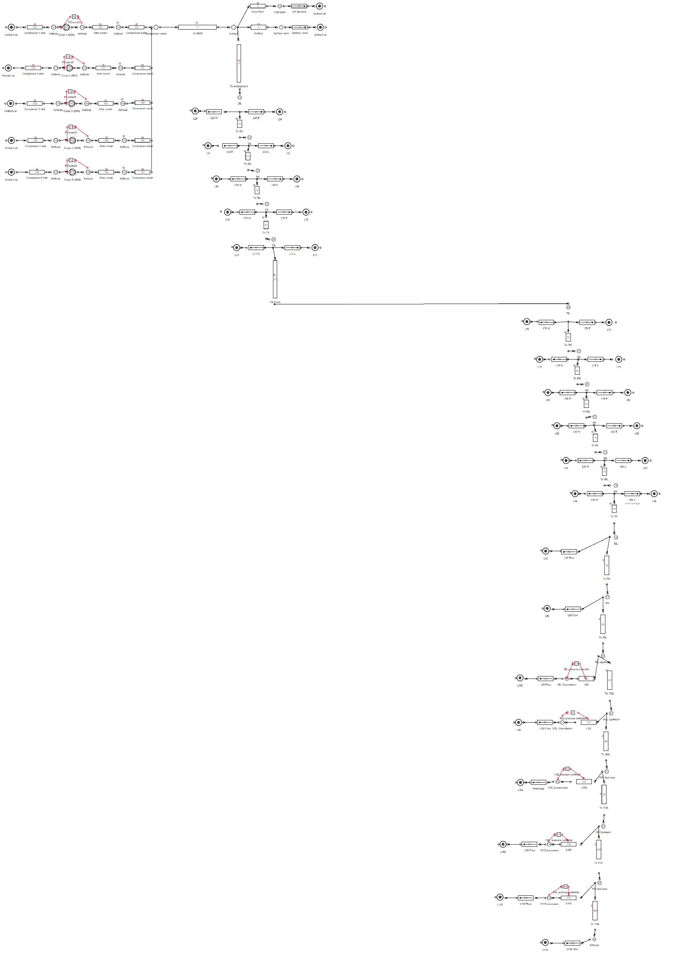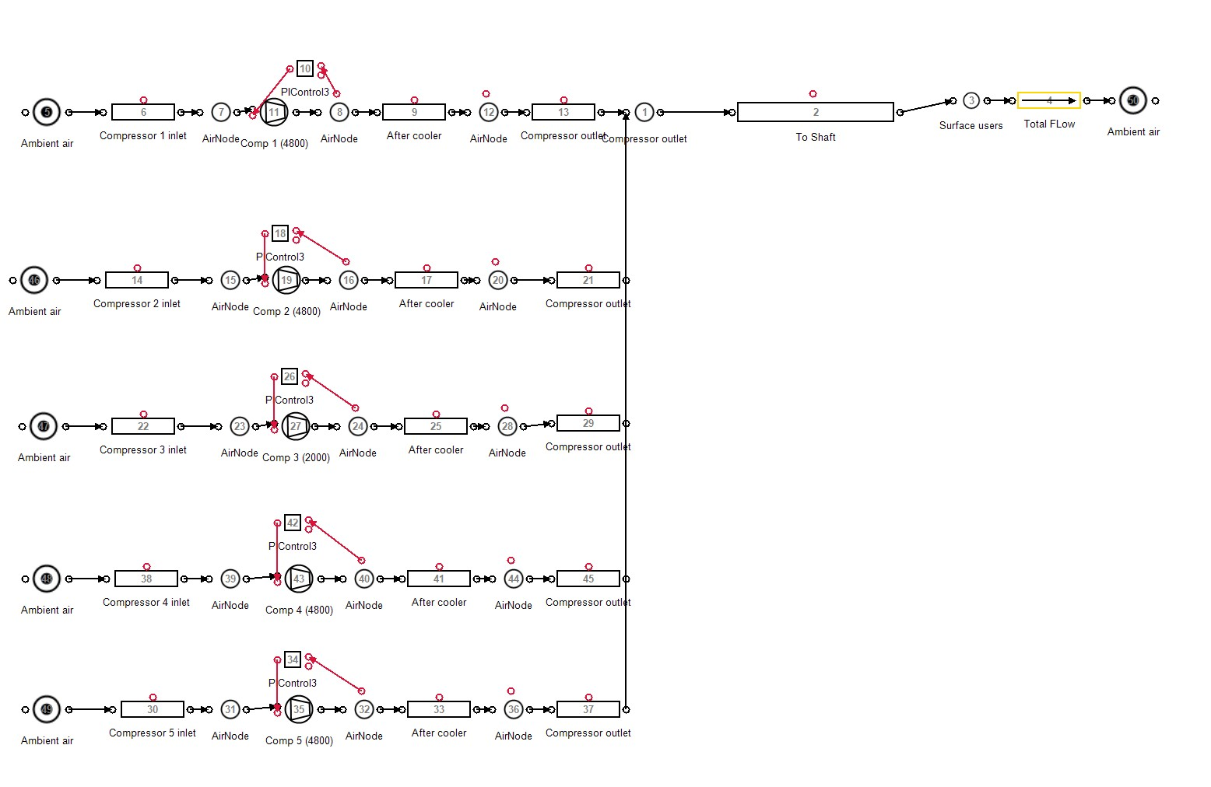

Simulation boundary

1

2

3

Figure 3.2: Model boundary selection examples.

The boundaries should be chosen based on the input data available, required accuracy n and available time and resources. A more detailed model will lead to more accurate simulation, however it may take more time and resources to obtain the data required. Figure fig. 3.2 shows an example of different boundary selection for the same system.

The period and step size selected for the simulation is just as important. The period of the simulation should be determined to ensure a scenario is fully tested. Most commonly, a 24 hour period is chosen as daily parameters are normally very similar. The simulation step size should be selected with the resolution of the available data in mind. Smaller step size

selection can lead to a more accurate simulation model.

### Model compressed air network component

#### Air pipes

Pressure losses occur over compressed air networks due to friction in the pipe, these losses should be taken into account in the simulation for large piping sections. A pipe model is used to account for these losses which are defined by the *Darcy-Weisbach equation*1:

∆*P* =

*f LρV* 2

2*D*

Where the pressure difference ∆*P* is a function of:

Parameter Definition

*f* Friction coefficient

*L* Pipe length (*m*)

*D* Pipe diameter (*m*)

*ρ* Air density (*kg/m*3)

*V* Average velocity (*m/s*)

Table 3.1: Air pipe component model parameters.

The pipe component can be used as a valve by controlling the open fraction between 0 and 1. Modelling the valve flow characteristics is discussed in section 3.3.3 *Controllers*.

#### Ambient conditions

Ambient air condition underground and on surface change the characteristics of the air, effecting the operation of the system. fig. 3.3 shows the average summer air conditions. If no data is available for the specific simulation period, the conditions can be estimated by scaling this profile. The assumption is made that underground conditions remain constant at each mining level. Pressure and temperature increases with depth as a result of auto compression and rock face temperature. Therefore the conditions can be estimated using only the depth at each level.

#### Compressors

Three compressor models were investigated, each with varying complexity. The models are:

1 B. Glenn, ‘The Darcy–Weisbach Equation,’[Online] [https://bae.okstate.edu/faculty-sites/Darcy/](https://bae.okstate.edu/faculty-sites/Darcy/DarcyWeisbach/Darcy-WeisbachEq.htm) [DarcyWeisbach/Darcy-WeisbachEq.htm](https://bae.okstate.edu/faculty-sites/Darcy/DarcyWeisbach/Darcy-WeisbachEq.htm), [Accessed 20-05-2017]



|  |  |  |  |  |  |
| --- | --- | --- | --- | --- | --- |
|  |  |  |  |  |  |
|  |  |  |  |  |  |
|  |  |  |  |  |  |
|  |  |  |  |  |  |
|  |  |  |  |  |  |

Figure 3.3: Average summer ambient air conditions at a South African gold mine.

35

100

30

80

25

60

20

40

15

20

10

00:00

04:00

08:00

12:00

Time of Day

16:00

20:00

0

00:00

Temperature Relative Humidity

Relative Humidity (%)

Temperature ()*◦C*)

* + - * Air compressor
      * Dynamic compressor
      * Positive displacement compressor

The air compressor is a general, simplified model. It requires minimal user inputs by making several assumptions. This is useful when parameters for a compressor are not available. Or when doing a quick preliminary simulation. However, it is not ideal for detailed simulations which require more precision.

The dynamic compressor components are is more complex, taking into account factors such as heat generated by polytropic

coefficient and inefficiencies within the process. Hence, the model can be used more accurately and for more complex simulations than the general compressor model. However, it should be noted that the dynamic compressor is simplified by several assumptions, for example, a constant efficiency at varying loads.

For most scenarios, the dynamic compressor model is most suitable. This component is modelled by fitting a quadratic curve through three points of operation to obtain an equation for corrected mass flow as a function of the pressure ratio. This characteristic curve of compressor as shown in fig. 3.4 can be accurately estimated even when only one data point is available by making approximations for the zero flow and pressure points on the curve. Once the flow characteristics of the compressors are set, the efficiency and polytropic coefficient parameters are calibrated such that the output power and air temperature match the actual or estimated outputs of the compressor.

|  |  |  |  |  |  |  |  |
| --- | --- | --- | --- | --- | --- | --- | --- |
|  |  |  |  |  |  |  |  |
|  |  |  |  | *f* (*x*) | = *−*2*.*586 | *x*2 + 7*.*78 | 8*x* + 494 |
|  |  |  |  |  |  |  |  |
|  |  |  |  |  |  |  |  |
|  |  |  |  |  |  |  |  |
|  |  |  |  |  |  |  |  |

Figure 3.4: Estimating the characteristic curve of a compressor by fitting a quadratic function to points of operation.



500

400

300

200

100

0

0

2

4

6

8

Pressure ratio

10

12

14

16

Mass flow (*kg*3*/s/*/(*k*)*/Bar*)

Once the models are accurately calibrated, the compressor component is integrated to the air network in the arrangement shown in fig. 3.5. The Compressor is connected to the inlet air source via an inlet pipe and air node and to the rest of the network via an air node and outlet pipe. This is is to allow the inlet and outlet parameters and conditions to be be monitored and controlled.

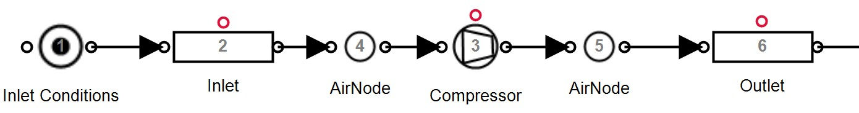

Figure 3.5: Integrating the compressor component into the simulation.

#### Demand/leak

A flow demand represents any air flow leaving the network. This includes equipment that uses air such as drills and agitators etc. as well as inefficiencies like leaks and open pipes. Generally the air flow is dependent on pressure and the specific resistance to flow of the outlet.

The resistance of the flow demand can be obtained using the inlet pressure, outlet pressure and flow. If the flow is not known, a reasonably accurate estimation can be made by calculating the expected flow from the size of the outlet. The air demand may vary throughout the day. For example, a mining section may utilise more machines during certain periods of the day. A schedule is used to replicate this in the simulation. fig. 3.6 shows how a calibrated air demand or leak is integrated into the simulation.

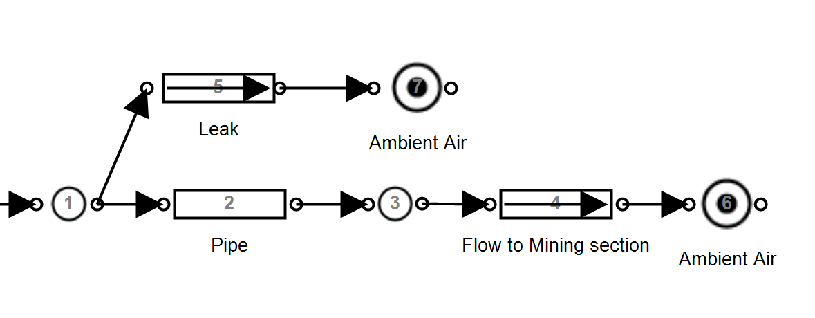

Figure 3.6: Implementing flow demands and leaks into the simulation.

#### Compressed air control

Simulation components need to be dynamically controlled as in the actual air network. Control is typically implemented on compressors and valves throughout the network to follow certain set-points and schedules. It is important to not only include the controllers in the simulation, but to replicate the non-linearities, limitations and responsiveness related to their use. This ensures the model reacts in the same way the actual network would, improving accuracy.

On a typical mine, compressors power is controlled to ensure that the discharge pressure matches a specified set-point. This control is achieved through either VSDs (or Variable Frequency Drives (VFDs)) and guide-vain control. VFDs provides a wide range of power control and can be estimated using a Proportional-Integral (PI) controller as in fig. 3.7 where discharge pressure is used as feedback for the controller. Guide vains are most commonly

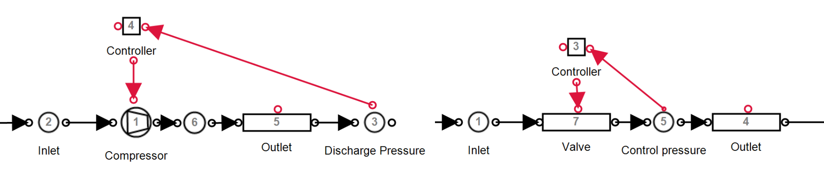

Figure 3.7: Control components in PTB.

used in mining to control compressors. This entails controlling the position of the inlet guide vain . The guide vain is opened or closed to control the compressors discharge pressure. Manipulating the guide vain position will affect the power the compressor inputs into the system. fig. 3.8 shows the relationship between power and guide vain position. This can be modelled as a linear function where a guide vain position of 40% relates to an output power of about 60% of the maximum power. When more pressure is required than can be obtained with the guide vains fully opened, another compressor is needed to operate.



Figure 3.8: Modelling the compressor control from a guide vain

120

100

80

60

40

20

0

0

20

40

60

80

100

120

Guide Vain Position (%)

Output power (%)

A guide vain controller is modelled using a PI controller component. However, the limitations of guide vain control, as represented in fig. 3.8, must be implemented in the controller. This is done by using a minimum output that would match the minimum power reduction the guide vain achieved by closing the guide vain. For example, a PI controller for the compressor from fig. 3.8 would have a minimum control output of approximately 60%.

Mines utilize control valves at underground sections to control the pressure at individual mining stations independently [44]. Controlling of valve components is performed similarly as control of the compressor components. As shown in fig. 3.7 the outlet pressure is used as feedback for a pi controller. The controller output is mapped to the valve fraction of a pipe component.

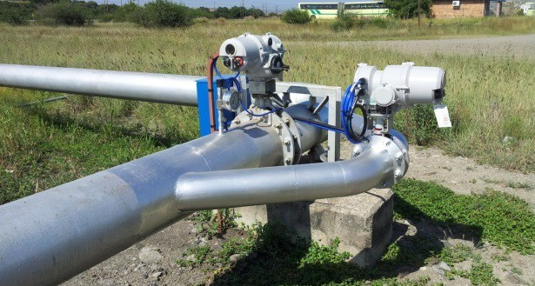

Figure 3.9: An example of a compressed air control valve[45].

Parameter Definition Unit

*A* The heat transfer area *m*2

*UA* Heat transfer coefficient *kW/◦C*

*Tamb* Ambient air temperature *◦C*

Table 3.2: The input parameters for the after-cooling simulation model .

#### Compressed air after-cooling

The air compression process generates significant heat. Compressed air at high temperatures contains a large amount of water vapour. To prevent condensation later in the air network, improve the system capacity and protect equipment from excessive heat, after-coolers are installed to the outlet of the compressor [20].

After-cooling reduces the compressed air temperature out of the compressors. This cooling can have an effect on the operation of the network. Hence, including after-cooling to the simulation model should improve accuracy. To replicate this effect, a heat transfer node can be added to the outlet of the compressor component. The heat transfer parameters shown in table 3.2 should be calibrated such that the air temperature matches after-cooled air temperature measurements. An assumption of 40 *◦*Celcius can be used if no measurements are available.

Depending on the accuracy requirement, after-cooling can be excluded from the simulation. Post after-cooling, compressed air is normally still warmer then ambient conditions. Air tem- peratures underground can be accurately matched by including heat transfer for compressed air pipelines.

### Verify simulation model

* Steps to validate the model accuracy - Compare parameters to actuals
* First principles - Comparison to other models

### Select simulation inputs

The inputs of a simulation are any parameters that do not remain static, or follow the same profile in day to day operation of the system. Examples of such parameters in a compressed air simulation are:

* + - * Surface ambient conditions
      * Machine operation schedules
      * Air demands
      * Operational changes

Changing the simulation baseline period for a calibrated simulation should only require the updating of the input parameters. fig. 3.10 shows an example of a changing compressor schedule where an input parameter would need to be updated in the simulation.

8

7

6

5

4

3

2

1

00:00

04:00

08:00

Period 1

12:00

Time of Day

Period 2

16:00

20:00

00:00

Compressor

|  |  |  |  |  |  |
| --- | --- | --- | --- | --- | --- |
|  |  |  |  |  |  |
|  |  |  |  |  |  |
|  |  |  |  |  |  |
|  |  |  |  |  |  |
|  |  |  |  |  |  |
|  |  |  |  |  |  |
|  |  |  |  |  |  |
|  |  |  |  |  |  |
|  |  |  |  |  |  |

Figure 3.10: An example of two baseline periods, showing a changed compressor schedule.

### Periodic simulation

Period simulation refers to the repetition of simulations over subsequent periods to determine the sequential accuracy of the model. This is important to verify the model is valid in general and not just a single period. This simulation will also indicate where operation changes have occurred as the simulation accuracy will be reduced.

The following process is followed to implement periodic simulation: Simulation input data is collected periodically for each simulation interval, this data includes only inputs that vary day to day such as schedules, air conditions and measured flows. Once the input values are collected, they are then imported into the compressed air model. The simulation performed and the output data is exported for analysis. The simulated data is then compared with the actual operation of the system and major discrepancies are identified. This process is triggered periodically.

### Summary

*Unfinished*

Data sources

Figure 3.11: The periodic simulation process that was followed in this analysis.

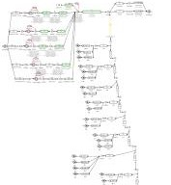

Simulation inputs

Repeat periodically

Import into

simulation model

Solve simulation

Export Simulation

output data

Analysis

## Implementation of simulation method

### Preamble

Once a simulation has been developed and verified, the implementation of interventions and scenarios follows. In this section, the approach of implementation the simulation methodology, and analysis of interventions will be discussed.

### Analyse data

* Baseline vs Optimised analysis
* identification of further improvements

*Unfinished*

### Quantify operational improvements

* Estimating cost savings
* Reporting feedback to the mine

*Unfinished*

### Summary

## Conclusion

**CHAPTER 4**

**Results and validation**

‘*Not everything that can be counted counts, and not everything that counts can be counted.*’ - Albert Einstein

## Introduction

This section will validate the simulation methodology through case studies. Mining compressed air systems were chosen as case studies based on the availability of data and the scope for energy and operational improvement. Two different mines were selected for the studies.

Three case studies were performed. In case study 1 and 2, improvements were simulated on mine A and mine B respectively. In Case study 3 periodic simulation analysis is implemented using the simulation developed for case study 2. From the results in the case studies, the potential benefits compressed air simulations for the South Africa mining industry is estimated and discussed.

## Case study 1. Simulated improvements on mine A

### System investigation

Mine A represents a group of three gold mining shafts and a gold processing plant in the Free state province. The mine shafts and gold plant share a compressed network. Prior to this study, efforts had been made to optimise the system through DSM energy projects. However, there may still be potential for further optimisation. An investigation was performed to gather data and understanding of the system and to identify potential energy and operation improvement strategies.

Inlet air

Figure 4.1: Simplified process flow chart of the compressed air network.

VK32

6

VK10

1

VK10

2

VK32

1

VK32

2

VK32

3

VK32

4

VK32

5

Gold Plant

Online

Standby

#1 Shaft

#2 Shaft

#3 Shaft



An air flow distribution layout was developed for the system, a simplified layout is shown in fig. 4.1. From this along with information from the mine personal and data, an understanding of the air network’s operation was obtained. The system typically utilises 5 *MW* of power. During the drilling shift the demand increases to 6 *MW* . fig. 4.2 show the average weekday

power profile between January and May 2016.

Power (*MW* )

6

5

4

3

2

1

0

00:00

04:00

08:00

12:00

Time of Day

16:00

20:00

00:00

Figure 4.2: Average power profile

Seven compresses are available in the system. Five large compressors (VK32) rated at 2.9 *MW* each and two smaller compressors (VK10) with a power rating of 1.1 *MW* each. No more than 4 compressors are required at any time, the other compressors are therefore on standby. Air is supplied to the sections in three mining shafts as well as a gold processing plant on the surface.

The mine normally operates the compressors with a constant pressure set-point of 500 kilopascals. The set-point is kept this high as the gold processing plant requires constant high pressure throughout the day. This makes it difficult to reduce the set-points of the compressor. It is possible to control the air supply pressure to the gold plant independently from the rest of the network. This is performed by controlling the surface valves.

The evening Eskom energy peak time was identified as a period where savings could be obtained. During this time, air is not required underground as blasting is scheduled. Due to the energy tariff structure, interventions during the energy peak also maximises the financial benefit for the mine. Compressor set- point control and underground valve control were identified as strategies to achieve these savings. Due to the risk of loss of production, the mine would not allow practically testing the scenario on the actual system. Simulation was therefore required to accurately calculate and analyse the benefits of the of compressor set points. A model was developed to test these scenarios.

### Model development

With the data and understanding of the gathered from the investigation, a model was developed using the PTB tool and the methodology discussed in Chapter 3. First, the

simulation boundary was selected to include the measured flows to each level underground, as well as the surface processing plant. For highest accuracy, the simulation step size was set to 30 minutes to match the available data resolution.

The simulation component models were developed and calibrated using the respective methods discussed in chapter 3. The following assumptions were made to simplify the model development:

* + - * The effect of compressed air after-cooling is negligible
      * Heat transfer over the pipe length is negligible
      * Underground temperature and humidity remained constant for each level
      * Surface ambient air conditions followed normal summer trend

The model components was calibrated so that the simulated outputs matched data from the real system. The process flow diagram for the simulation is shown in fig. II.1. The model data inputs and outputs are described in table 4.1.

Inputs Outputs

Level measured flows Compressor powers

Compressor schedules Network flows Compressor set-points Network pressures Underground valve set-points

Table 4.1: Data inputs and outputs for the Case study 1 simulation model

### Verification of model

Verification was performed to ensure that simulated output accuracy was *>* 95%. fig. 4.3, fig. 4.3 and fig. 4.5 show the to total simulated power ,flow and outlet pressure of the compressors compared to the system. The average accuracy for the power and total flow was 97.34% and 97.01% Respectively . Both these parameters were well within the target 95% accuracy. The accuracy of the outlet pressure was 99.1%. This was expected simulated pressure was expected as the mine uses a constant pressure set-point for the compressors.

Accuracy of the model was checked in more detail to ensure that each modelled parameter matched the actual measurement with high accuracy. table III.1 shows the accuracy each measured simulation output in the model.

%*error*

8

7

6

5

4

3

2

1

0

00:00

04:00

08:00

12:00

16:00

20:00

0

00:00

Figure 4.3: The simulated power compared to the actual measurement

20

10

Time of Day

Baseline power Simulated power Error

15

20

10

5

10

Time of Day

Baseline flow Simulated flow Error

Flow (*kg/s*)

Power (*MW* )

%*error*

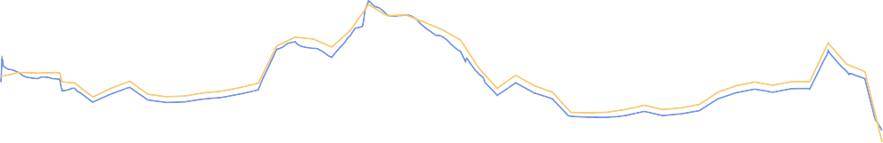

0

00:00

04:00

08:00

12:00

16:00

20:00

0

00:00

Figure 4.4: The simulated flow compared to the actual measurement

20

10

Time of Day

Baseline press. Simulated press. Error

Pressure (*kPa*)

%*error*

600

550

500

450

400

350

300

00:00

04:00

08:00

12:00

16:00

20:00

0

00:00

Figure 4.5: The simulated Pressure compared to the actual measurement

### Scenario 1. Compressor set points

The Eskom evening peak tariff time occurs during the blasting shift. During this shift, the pressure requirements underground are lower than the rest of the day. Reducing pressure in the network reduces power as less work is required from the compressors. Additionally, losses caused leaks, open valves, etc. are reduced. However, lowering the pressure set-point of the compressors requires independently controlling the air to the gold plant.

Using the verified simulation model, the compressor set-points were reduced to 420 kilopascals, the minimum allowed compressor set-point during the drilling shift. The compressor schedule was changed to allow independent control of the gold plant pressure. Gold plant pressure was maintained at 490 kilopascals.

The results of the simulation, shown, in fig. 4.6, indicated an average power reduction of

0.46 MW Peak-clip (P.C.). This energy optimisation relates to a R0.37 M Per annum (p.a) energy cost saving to the mine.

6

2

1*.*5

4

1

2

0*.*5

Power (*MW* )

Power Saving (*MW* )



0

00:00

04:00

08:00

12:00

Time of Day Intervention

16:00

20:00

0

00:00

Baseline

Power saving

Figure 4.6: Energy savings by reducing compressor set-points

### Scenario 2. Control valves set points

An alternative scenario is to reduce the pressure at the control valves at each level. By reducing pressure at the control, set-points can be lowered to the minimum requirement per level. This can lead to higher savings than could be achieved through compressor set-points. This scenario would be relatively easy to implement as it does not require any changes to the compressor control schedule.

Air pressure set-points were reduced to 300 kPa at the underground control valves during the

evening peak period. Analysis of the simulation results showed a 1MW average P.C. saving. The intervention would lead to an annual cost saving of R0.91M.

6

2

1*.*5

4

1

2

0*.*5

Power (*MW* )

Power Saving (*MW* )



0

00:00

04:00

08:00

12:00

Time of Day Scenario

16:00

20:00

0

00:00

Baseline

Power saving

Figure 4.7: Power savings

### Comparison of scenario results

Comparing the scenarios in table 4.2 showed that Scenario 2 had a larger peak energy impact then scenario 1. Further savings could be achieved through a combination of the two scenarios as well as investigating set-point reductions during other periods of the day.

|  |  |  |
| --- | --- | --- |
| Scenario | Power saving | Cost saving p.a |
| **Scenario 1 results**  Reducing compressor set-points | 0*.*46 MW P.C. | R0.37M |

#### Scenario 2 results

Reducing underground pressure during evening peak 1*.*0 MW P.C. R0*.*91M

Table 4.2: Comparison of Mine A’s simulated scenarios

### Validation of results

Scenario 2 was implemented on the actual compressed air system. An energy saving of just under 1 MW P.C. was recorded when compared with the 2016 power baseline profile. These results matched the simulated scenario closely. fig. 4.8 shows the practical result compared with the simulated and baseline power profiles.

### Summary

A case study was implemented mine compressed air network in the Freestate. Following the simulation methodology, An investigation was performed to gather data and identify

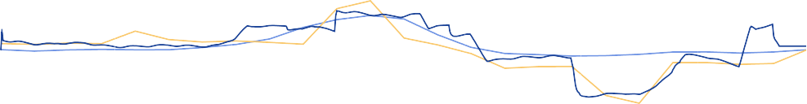

0

00:00

04:00

08:00

12:00

Time of Day

16:00

20:00

0

00:00

Baseline Actual

Simulation

Power saving

Figure 4.8: Actual power savings achieved on the system

6

2

4

1*.*5

1

2

0*.*5

Power (*MW* )

Power Saving (*MW* )

potential interventions. A simulation model was developed to test scenarios. The tested interventions showed a P.C. saving of 1 MW which would result in a cost saving of R0.9M. The simulated was validated by implementation on the actual system leading to similar results.

## Case study 2: Simulated improvements on mine B

### System investigation

Case study B is large South African gold mine. The mine utilises five compressors supply compressed air to various surface and underground operations. An investigation was performed to gather the data and information required to build a simulation model of the network. As well as to identify potential simulation scenarios.

Inlet air

Figure 4.9: Basic layout of the compressed air network.

Surface

Compressor 1 Compressor 2 Compressor 3 Compressor 4 Compressor 5

Main shaft

Online

Standby

Sub Shaft



A basic air distribution layout was developed for the system. Figure II.?? illustrates the system in detail, indicating instrumentation, meters as well as normal airflow splits to various sections and levels of the mine.

Data related to the mines scheduling as well as critical limits and set-points of the compressed air system was obtained from various mine personnel. From this a general understanding of the operation was obtained. Important data parameters such as Power, pressures and flows of the system were gathered from the SCADA as well other data measurement sources. This data will be used to develop and calibrate the simulation model

Per-level investigations were performed on the significant mining levels to map and measure the locations and air usage for the cross-sections, refuge bays, major leaks and other compressed air consumers on each level. An example of a resultant schematic from the underground investigation is shown in fig. I.1. The information gathered from the system investigations was then utilised to develop and calibrate a simulation model.

### Model development

Using the data obtained from the investigations on the network, a simulation model was developed in PTB. The methodology described in Chapter 3 was utilised in this process. . The following assumptions made to simplify the model development:

* + - * After cooling reduced compressed air temperature from 60*o* Celcius to 40*o* Celcius
      * Underground temperature and humidity remained constant for each level

The boundaries of the baseline simulation were selected based on the available data for the network. The developed simulation model is shown in fig. II.2. For maximum accuracy, the simulation step size was set to the two minutes intervals to match the resolution from the data source. The model components was calibrated so that the simulated outputs matched data from the real system. The process flow diagram for the simulation is shown in fig. II.2. The model data inputs and outputs are described in table 4.1.

Inputs Outputs

Level measured flows Compressor powers

Compressor schedules Network flows

Set-points Network pressures

Table 4.3: Simulation inputs and outputs

#### Verification of baseline simulation

Using the verification methodology, the simulation model verified by comparing the simulation outputs to actual measured values. The compressors outlet pressure often does not match the set-point. To simplify the verification, the measured outlet pressure is temporarily used as set points for the compressors. This ensured that the pressure in the network is identical to that of the actual system as shown in fig. 4.10.

450

20

400

350

10

Time of Day

Baseline press. Simulated press. Error

Pressure (*kPa*)

%*error*



300

00:00

04:00

08:00

12:00

16:00

20:00

0

00:00

Figure 4.10: Comparing the pressure response of simulation to the actual measured pressure With the simulated pressure identical to the actual, the power and air flow outputs were

compared with their relative actual values. fig. 4.11 shows the comparison of the total power and flow of the system with the actual measure values for that same period. The accuracy for these parameters compared to the real system was 98*.*7% and 99*.*0% respectively. This was within the acceptable error.

50

20

40

10

Time of Day

Baseline flow Simulated flow Error

flow (*kg/s*)

%*error*

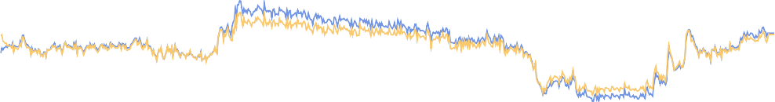

30

00:00

04:00

08:00

12:00

16:00

20:00

0

00:00

(a)

20

10

Time of Day

Baseline power Simulated power Error

Power (*MW* )

%*error*



15

14

13

12

11

10

9

8

00:00

04:00

08:00

12:00

16:00

20:00

0

00:00

(b)

Figure 4.11: Verification of the total (a) flow and (b) power of the system using the actual pressure profile.

Once the power and flow parameters were verified with acceptable error, the actual pressure set-point profile was imported to the compressor controllers. The simulated outlet pressure was then compared to the actual measured pressure and set-point, this is shown in fig. 4.12. The accuracy of the compressor outlet pressure was acceptable at 99.02 %. To ensure the model accuracy, all measured flows and pressures were compared to the simulated outputs. This comparison is shown in table III.2.

### Scenario 1. Refuge bay optimisation

From investigation, unnecessary refuge bay leaks were identified as a significant inefficiency that can be reduced. A test on a single mining level was performed to measure the potential flow saving of reducing refuge bay leaks. The test showed that by reducing refuge bay leaks,

%*error*

300

00:00

04:00

08:00

12:00

Time of Day

16:00

20:00

0

00:00

Actual Set-point

Simulation. Error

Figure 4.12: Verifying the Pressure response of the system given the pressure set points as inputs

450

20

400

350

10

Pressure (*kPa*)

by closing the valves, would lead to an average air saving of 0*.*05 *kg/s* per refuge bay at typical operational pressures. This measurement was conservative as it was not possible to close all the refuge bays on the level for the test.

Due to the size of the mine, extending these tests to include the rest of the mining sections was not practical. Therefore, the benefits of an intervention on the entire mine could not accurately be determined from practical tests. Using simulation the typical operation with can be accurately compare with the intervention scenario to quantify the potential financial and operational benefits throughout a given period.

The simulation model boundaries was updated to include refuge bay leaks on each level. For each refuge chamber, a air leak was added to the model by utilising per level layouts indicating locations of refuge bays. These leaks were modelled as flow demands using the data from the initial refuge bay tests. The overall mass flow of the system was maintained to ensure model accuracy. T By adding the flow component in the actual location in the process, the pressure to each chamber is correctly modelled. The full simulation model is shown in fig. II.3. The updated simulation model was re-checked to ensure accuracy. This model was used as a baseline to quantify saving for the scenario.

To create the optimised scenario, the refuge bay flow components were set to 0 *kg/s*. The simulation was performed and the output data compared ot the baseline. fig. 4.13 shows the baseline power compared to the optimised scenario. The comparison showed a potential 0.92 MW improvement in Energy efficiency (E.E.) through optimisation of refuge bay leaks. The optimised scenario would lead to a R5.13M energy cost saving for the mine.

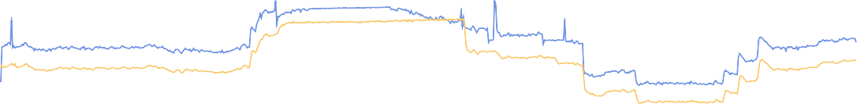

0

00:00

04:00

08:00

12:00

Time of Day Optimised

16:00

20:00

00:00

Baseline

Power saving

Figure 4.13: The Baseline system power compared to the system power when refuge bay leaks are reduced.

15

10

5

Power (*MW* )

An additional pressure benefit was identified during the drilling shift, shown in fig. 4.14. The reduced flow lead to a pressure increase of about 15 kpa. The pressure increase could lead to an increase in drilling efficiency.

440

420

400

380

Pressure (*kPa*)

11 15 15 15 15 14 19 9 7

360

00:00

04:00

08:00

12:00

Time of Day

16:00

20:00

00:00

Baseline Optimisation

Figure 4.14: The Baseline system pressure compared to the system pressure when refuge bay leaks are reduce.

### Scenario 2. Closing off levels and inactive work areas

Due to the high prevalence of compressed air misuse, leaks and open valves, significant amounts of air is still used during periods where it is not required. Reducing pressure to areas during these times may lead to a major power and cost saving. Using simulation, tests can be done to identify the benefits of reducing pressure to inactive mining sections.

Strategies to reduce airflow during peak times was simulated for level 105L. The level was modelled to include all major leaks, refuge bays and drilling sections that were manually identified from the level investigation. This is shown in the simulation diagram shown in fig. 4.15. Station control, in-stope control and a combination were simulated were all

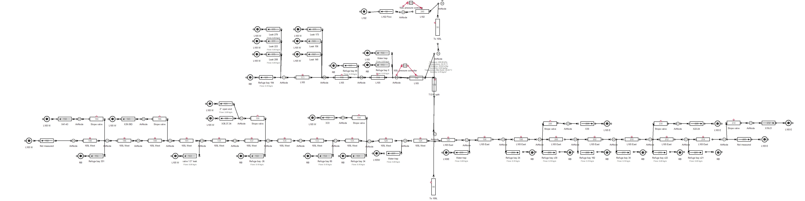

Figure 4.15: Underground level layout.

simulated for 105L. Station control means control of the pressure of at the station of the level. In-stope control is control of the is cut the airflow to the mining section during certain periods. fig. 4.16 shows the effect the various interventions have on the flow for 105L compared to the baseline.

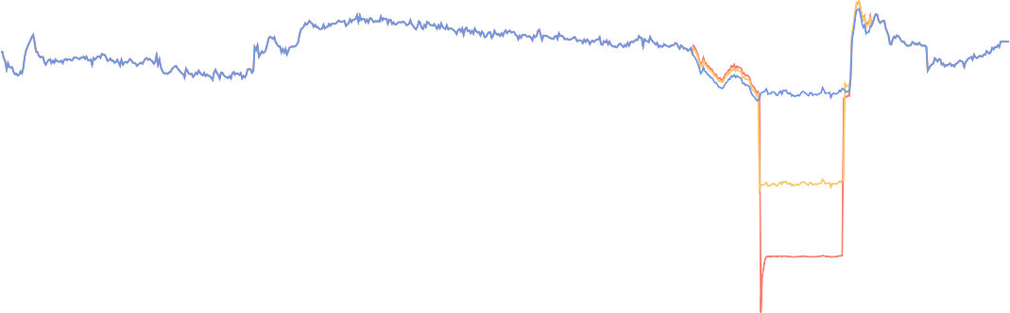

4*.*5

4

3*.*5

3

2*.*5

2

1*.*5

1

0*.*5

0

00:00

04:00

08:00

12:00

Time of Day In-stope control

16:00

20:00

00:00

Station control

Baseline

Flow (*kg/s*)

|  |  |  |  |  |  |
| --- | --- | --- | --- | --- | --- |
|  |  |  |  |  |  |
|  |  |  |  |  |  |
|  |  |  |  |  |  |
|  |  |  |  |  |  |
|  |  |  |  |  |  |
|  |  |  |  |  |  |
|  |  |  |  |  |  |
|  |  |  |  |  |  |
|  |  |  |  |  |  |

Figure 4.16: Flow reduction during blasting period for 105 level

Station control had the largest impact on the flow usage for the level. This reflects with the

power reduction achieved for each intervention shown in fig. 4.17. The impact was 0.4 and

0.7 MW for the stope and station intervention respectively.

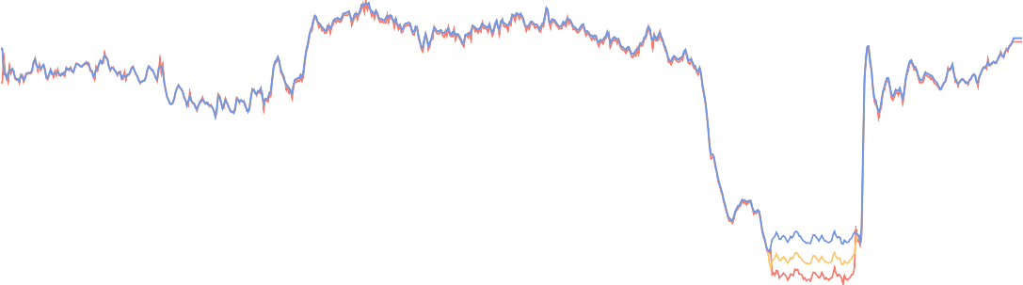

Power (*MW* )

|  |  |  |  |  |  |
| --- | --- | --- | --- | --- | --- |
|  |  |  |  |  |  |
|  |  |  |  |  |  |
|  |  |  |  |  |  |
|  |  |  |  |  |  |

Figure 4.17: Comparing simulated flow interventions on 105L.

14

12

10

8

00:00

04:00

08:00

12:00

Time of Day In-stope control

16:00

20:00

00:00

Station control

Baseline

A simulation was done to estimate the potential savings of extending the evening station control to other levels. This was performed by updating the flow demands for levels 95- 115 to match the flow saving achieved in the 105L simulation. The savings achieved for the general station control were 2.0 MW P.C., shown in fig. 4.18. It was calculated that this would lead to a annual energy cost saving of R2.5M.

12

8

4

Power (*MW* )

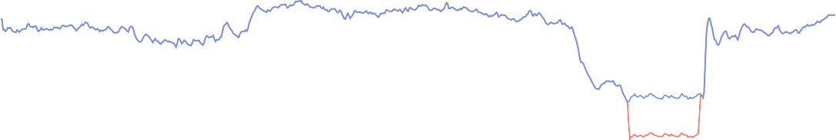

0

00:00

04:00

08:00

12:00

Time of Day Power Savings

16:00

20:00

00:00

Intervention

Baseline

Figure 4.18: Energy saving achieved by general peak time Station control

### Comparison of interventions

The interventions were then compared for feedback to the mine. The refuge bay intervention is recommended as it will achieve the highest energy cost saving.

Scenario Power saving

#### Scenario 1 results

Cost saving (p.a)

Additional benefit

Refuge bay leakage reduction 0*.*92 MW E.E. R5.17M Increase in drilling

pressure

#### Scenario 2 results

105L peak time in-Stope control 0*.*4 MW P.C. R0*.*3M - 105L peak time Station control 0*.*7 MW P.C. R2*.*5M - General peak time Station control 2*.*0 MW P.C. R2*.*5M -

Table 4.4: Comparison of the simulated scenarios

### Validation of results

* Awaiting results on manual tests -

### Summary

* Unfinished

## Case study C: Periodic simulation analysis

### Preamble

Updating the inputs of a simulation periodically could be used to verify simulation model accuracy. If the precision of simulation outputs remains for subsequent days, this would indicate that the model is correctly calibrated. Additionally, this process could be used to identify significant operational changes that occur within the system. This would cause the simulation outputs to differ from the actual measured parameters.

A daily periodic simulation analysis was implemented between 2016/11/01 and 2016/11/30 using the periodic simulation methodology discussed in Chapter 3. The simulation model developed for case study A was used for the analysis. The simulation receives the data inputs shown in table 4.5.

Inputs Outputs

Ambient air conditions Compressor power Measured flows Flows

Compressor schedules Pressures

Table 4.5: Data inputs and outputs for the simulation

### Results

The process was triggered daily. For each period, data inputs shown in table 4.5 were imported into the model, the simulation was then processed and the outputs are compared with the real system parameters. fig. 4.19 shows the average daily accuracy of the simulated total system power, flow and the shaft pressure per period.

Date of simulation

Flow Pressure Power

Accuracy (%)

100

95

90

85

80

2016/11/01

2016/11/07

2016/11/13

2016/11/19

2016/11/25

Figure 4.19: The flow, pressure and power error percentages for daily periodic simulations over a month.

The accuracy of the process parameters of the simulation was within 5% for the duration of the periodic simulation. However, From the 2016/11/07, the accuracy of the simulated power dropped by between 10 and 15 percent. The daily average power of the system up to the point was approximately 12.5 MW, a 15% simulation error therefore relates to 1.9 MW difference between simulated and actual parameters. This suggests a major shift in operation of the system.

An analysis was done to try determine the source of the discrepancy. From the data it was identified that the simulated power for compressor 1 was the source of the different A look at the actual power measurement for compressor 1 show drop compared to normal operation by almost 2 MW. At the same time the power used per kg/s of air seemed to have dropped. fig. 4.20 shows the average daily power for compressor 1 (blue), compared to the air mass flow per Watt(yellow). As a 2 MW shift in power is not likely from, the results seem to

Periodic simulation

4000

5

1000

2016/09/01

2

2016/10/01

2016/11/01

Date

2016/12/01

Compressor 1 average power System efficiency

Power (kW)

*FlowperWatt*(*kg/s/W* )

|  |  |  |  |  |  |
| --- | --- | --- | --- | --- | --- |
| 3500 |  |  |  |  | 4*.*5 |
| 3000 |  |  |  |  | 4 |
| 2500 |  |  |  |  | 3*.*5 |
| 2000 |  |  |  |  | 3 |
| 1500 |  |  |  |  | 2*.*5 |

Figure 4.20: Supply efficiency and Compressor 1’s average power output over the time of the periodic analysis.

show that there was a fault in the power metering starting from 2016/11/07. This explains the perceived increase in efficiency over the same period as a less power is measure then is actually being provided. In this situation the simulated power measurement is actually a more accurate metric for compressor 1’s power over this period.

### Validation

To validation of misreadings from the power meter from comparing independent power data for the substation to the combined individual compressors meters.fig. 4.21 shows the measured power from the two sources. By comparing the compressor power to the independent data, it is clear that there is an error in measurement as hypothesised.

### Summary

Power (MW)

Figure 4.21: Comparison using alternative power source.

14

12

10

8

05/11/2016 10/11/2016 15/11/2016 20/11/2016 25/11/2016 30/11/2016

Date

Compressor power measrement Independant measurement

## Potential benefit for SA mines

There are proximately 75 operational gold and Platinum group metal (PGM) mines in South Africa, as illustrated in fig. 4.22 1*,*2. Each mine utilises compressed air for underground processes. By utilising the compressed air simulation methodology in this study, the mines could collectively achieve significant energy and cost savings for the industry.

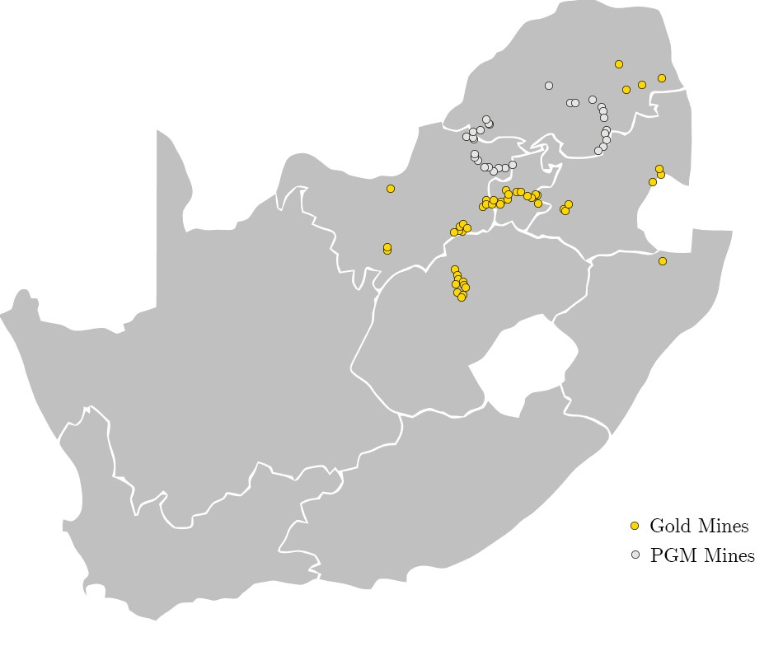

Figure 4.22: Gold and PGM mines in South Africa1*,*2.

In this study, the simulated interventions resulted in savings of (on average) 0.69 MW E.E. or 1.025 MW P.C.. Assuming similar intervention were identified, through simulation for all gold and platinum mines. A potential energy saving of approximately 50 MW E.E. or 75 MW P.C. could be achieved. The combined cost saving for these interventions would amount to up to R400M p.a.

1 Chamber of Mines, [Online] <http://www.chamberofmines.org.za/sa-mining/gold>, [Accessed 16-06- 2017]

2 Chamber of Mines, [Online] <http://www.chamberofmines.org.za/sa-mining/platinum>, [Accessed 16- 06-2017]

## Conclusion

* Unfinished

## CHAPTER 5

**Conclusion**

‘*Quote.*’ - Somebody

Chapter 5. Conclusion

## Conclusion

## Limits of this study

## Recommendations for future studies

## Bibliography

[1] P. Mar´e, ‘‘Novel simulations for energy management of mine cooling systems,’’ Ph.D. thesis, North-West University, 2016.

[2] P. Neingo and T. Tholana, ‘‘Trends in productivity in the south african gold mining industry,’’ *Journal of the Southern African Institute of Mining and Metallurgy*, vol. 116, no. 3, pp. 283--290, 2016.

[3] Eskom, ‘‘Revenue application - multi year price determination 2013/14 to 2017/18 (mypd3),’’ [Online] [http://www.eskom.co.za/CustomerCare/MYPD3/Documents/](http://www.eskom.co.za/CustomerCare/MYPD3/Documents/NersaReasonsforDecision.pdf) [NersaReasonsforDecision.pdf](http://www.eskom.co.za/CustomerCare/MYPD3/Documents/NersaReasonsforDecision.pdf), 2013, [Accessed 22 March 2017].

[4] G. M. Mudd, ‘‘Global trends in gold mining: Towards quantifying environmental and resource sustainability,’’ *Resources Policy*, vol. 32, no. 1, pp. 42--56, 2007.

[5] J. Mu¨ller and H. Frimmel, ‘‘Numerical analysis of historic gold production cycles and implications for future sub-cycles,’’ *The Open Geology Journal*, vol. 4, no. 1, pp. 29--34, 2010.

[6] J. Vosloo, L. Liebenberg, and D. Velleman, ‘‘Case study: Energy savings for a deep-mine water reticulation system,’’ *Applied Energy*, vol. 92, pp. 328--335, 2012.

[7] Eskom Demand Side Management Department, ‘‘The energy efficiency series - towards an energy efficient mining sector,’’ [Online] [http://www.eskom.co.za/sites/idm/Documents/](http://www.eskom.co.za/sites/idm/Documents/121040ESKD_Mining_Brochure_paths.pdf) [121040ESKD Mining Brochure paths.pdf](http://www.eskom.co.za/sites/idm/Documents/121040ESKD_Mining_Brochure_paths.pdf), February 2010, [Accessed 19 March 2017].

[8] H. Le Roux, ‘‘Energy consumption reduction challenge,’’ *Mining Weekly, PO Box*, vol.

75316, p. 30, 2005.

[9] J. Marais, ‘‘An integrated approach to optimise energy consumption of mine compressed air systems,’’ Ph.D. thesis, North-West University, 2012.

[10] L. Padachi *et al.*, ‘‘Energy efficiency through the integration of compressed air supply control with air network demand control,’’ in *Proceedings of the Sixth Conference on the Industrial and Commercial Use of Energy*. Citeseer, 2009, pp. 77--80.

[11] J. Du Plessis and R. Pelzer, ‘‘Development of an intelligent control system for mine com- pressor systems,’’ in *Industrial and Commercial Use of Energy (ICUE), 2011 Proceedings of the 8th Conference on the*. IEEE, 2011, pp. 59--63.

[12] J. Neale and P. Kamp, ‘‘Compressed air system best practice programmes: What needs to change to secure long-term energy savings for new zealand?’’ *Energy Policy*, vol. 37, no. 9, pp. 3400--3408, 2009.

[13] Marais *et al.*, ‘‘Simplification of mine compressed air systems,’’ in *Industrial and Com- mercial Use of Energy Conference (ICUE), 2013 Proceedings of the 10th*. IEEE, 2013, pp. 1--8.

[14] A. van Jaarsveld, S. Ebben, and A. Ashanti, ‘‘Development and implementation of an electrically powered stope rockdrill for tau tona mine,’’ in *SAIMM Narrow Vein and Reef Conference, Sun City, South Africa*, 2008.

[15] P. Fraser, ‘‘Saving energy by replacing compressed air with localized hydropower systems: a ‘half level’model approach,’’ *Platinum in Transformation*, 2008.

[16] A. van Tonder, ‘‘Sustaining compressed air dsm project savings using an air leakage management system,’’ Masters dissertation, North-West University, 2011.

[17] D. Brake and G. Bates, ‘‘Criteria for the design of emergency refuge stations for an underground metal mine,’’ in *AusIMM Proceedings*, vol. 304, no. 2. The Australian Institute of Mining and Metallurgy, 1999, pp. 1--8.

[18] C. Kriel, ‘‘Modernising underground compressed air dsm projects to reduce operating costs,’’ Masters dissertation, North-West University, 2014.

[19] L. B. N. Laboratory, *Improving Compressed Air System Performance: A Sourcebook for Industry*, 2nd ed. Washington DC: US Department of Energy, 2004.

[20] F. Schroeder, ‘‘Energy efficiency opportunities in mine compressed air systems,’’ Masters dissertation, North-West University, 2009.

[21] J. Snyman, ‘‘Integrating various energy saving initiatives on compressed air systems of typical south african gold mines,’’ Masters dissertation, North-West University, 2010.

[22] Kocsis *et al.*, ‘‘The integration of mine simulation and ventilation simulation to develop a ‘life cycle’ mine ventilation system,’’ *Application of Computers and Operations Research in the Minerals Industries, South African Institute of Mining and Metallurgy*, pp. 223-- 230, 2003.

[23] J. Banks, *Handbook of simulation: principles, methodology, advances, applications, and practice*. John Wiley & Sons, 1998.

[24] P. Peach, ‘‘Optimising deep-level mine refrigeration control for sustainable cost savings,’’ Masters dissertation, North-West University, 2016.

[25] J. Marais and M. Kleingeld, ‘‘An expert control system to achieve energy savings on mine compressed air systems,’’ *Industrial and commersial use of energy (ICUE)*, 2010.

[26] W. Booysen, ‘‘Reducing energy on rsa mines through optimised compressor contrl,’’ Masters dissertation, North-West University, 2010.

[27] W. Booysen *et al.*, ‘‘Optimising compressor control strategies for maximum energy savings,’’ *ICUE, Cape Town*, pp. 10--12, 2009.

[28] R. Saidur *et al.*, ‘‘A review on compressed-air energy use and energy savings,’’ *Renewable and Sustainable Energy Reviews*, vol. 14, no. 4, pp. 1135 -- 1153, 2010.

[29] J. Bredenkamp, ‘‘Reconfiguring mining compressed air networks for cost savings,’’ Masters dissertation, North-West University, 2013.

[30] A. J. M. Van Tonder, ‘‘Sustaining compressed air dsm project savings using an air leakage management system,’’ in *Industrial and Commercial Use of Energy (ICUE), 2011 Proceedings of the 8th Conference on the*. IEEE, 2011, pp. 133--137.

[31] B. Pascoe, ‘‘Improving mine compressed air network efficiency through demand and supply control,’’ Masters dissertation, North-West University, 2016.

[32] J. Marais, M. Kleingeld, and R. Pelzer, ‘‘Increased energy savings through a compressed air leakage documentation system,’’ *ICUE, SA*, vol. 11, 2009.

[33] M. Kleingeld and J. Marais, ‘‘A high level strategy plan for reducing a mine group’s dependence on compressed air,’’ *Proc. Industrial and Commercial Use of Energy (ICUE), Cape Peninsula University of Technology*, 2010.

[34] Bester *et al.*, ‘‘The effect of compressed air pressure on mining production and energy demand,’’ in *Industrial and Commercial Use of Energy Conference (ICUE), 2013 Proceedings of the 10th*. IEEE, 2013, pp. 1--4.

[35] C. Cilliers, ‘‘Benchmarking electricity use of deep-level mines,’’ Ph.D. thesis, North-West University, 2015.

[36] van Niekerk *et al.*, ‘‘The value of simulation models when implementing mine dsm projects,’’ in *Industrial and Commercial Use of Energy Conference (ICUE), 2013 Proceedings of the 10th*. IEEE, 2013, pp. 1--4.

[37] W. van Niekerk, ‘‘The value of simulation models for mine dsm projects,’’ Masters dissertation, North-West University, 2012.

[38] A. Holman, ‘‘Benefits of improved performance monitoring of mine cooling systems,’’ Masters dissertation, North-West University, 2014.

[39] Y.-j. Xu, S.-j. Zhang, and Y.-h. Xiao, ‘‘Modeling the dynamic simulation and control of a single effect libr--h 2 o absorption chiller,’’ *Applied Thermal Engineering*, vol. 107, pp. 1183--1191, 2016.

[40] A. Gous, W. Booysen, and W. Hamer, ‘‘Data quality evaluation for measurement and verification processes,’’ in *Industrial and Commercial Use of Energy (ICUE), 2016 International Conference on the*. IEEE, 2016, pp. 9--15.

[41] L. Meijsen, J. van Rensburg, and W. Booysen, ‘‘Verification procedures to ensure consistent energy metering,’’ in *Industrial and Commercial Use of Energy (ICUE), 2015 International Conference on the*. IEEE, 2015, pp. 138--146.

[42] S. V. Niekerk, ‘‘Quantification of energy consumption and production drivers in steel manufacturing plants,’’ Masters dissertation, North-West University, 2016.

[43] H. J. V. Rensburg, ‘‘Structuring mining data for rsa section 12l ee tax incentives,’’ Masters dissertation, North-West University, 2016.

[44] G. Heyns, ‘‘Challenges faced during implementation of a compressed air energy savings project on a gold mine,’’ Masters dissertation, North-West University, 2014.

[45] M. H. P. Van Niekerk, S. van Heerden, and J. van Rensburg, ‘‘The implementation of a dynamic air compressor selector system in mines,’’ in *Industrial and Commercial Use of Energy (ICUE), 2015 International Conference on the*. IEEE, 2015, pp. 129--132.

## APPENDIX I

**Network layout diagrams**

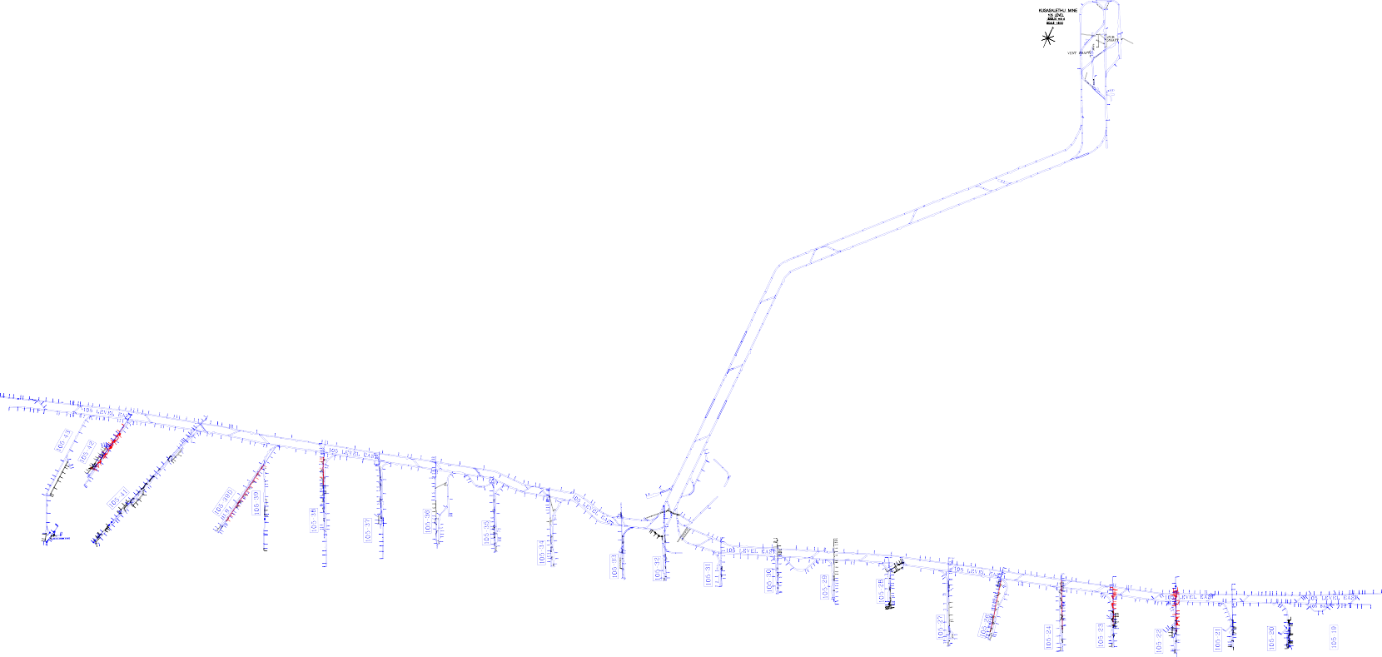

Appendix I.

Network layout diagrams

Figure I.1: Underground level layout.

*Simulating improvements on mining compressed air systems*

65

## APPENDIX II

**Simulation process Flow diagrams**

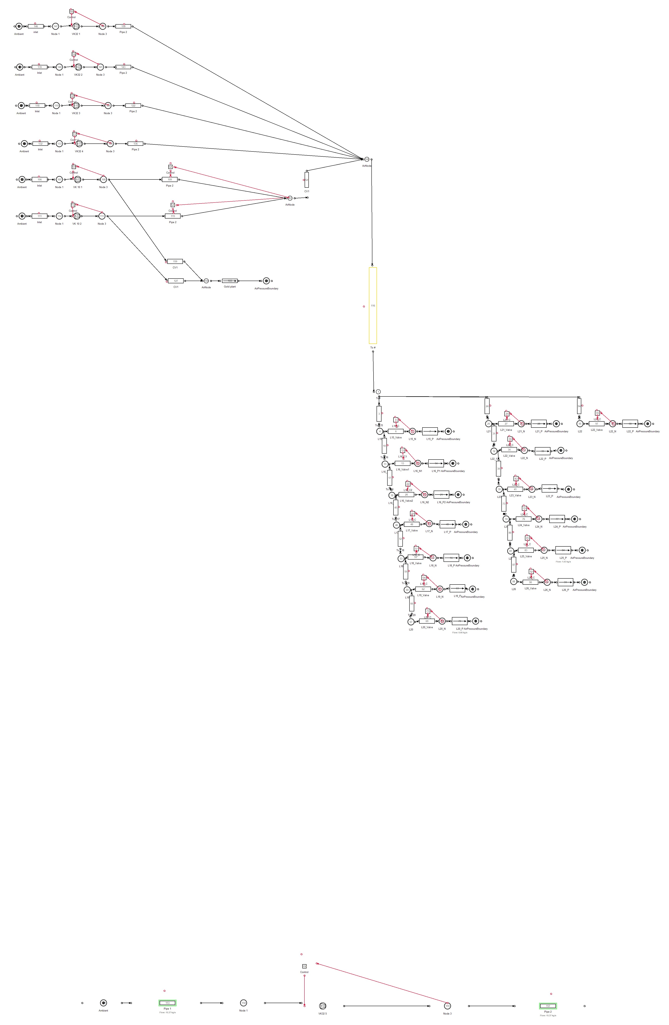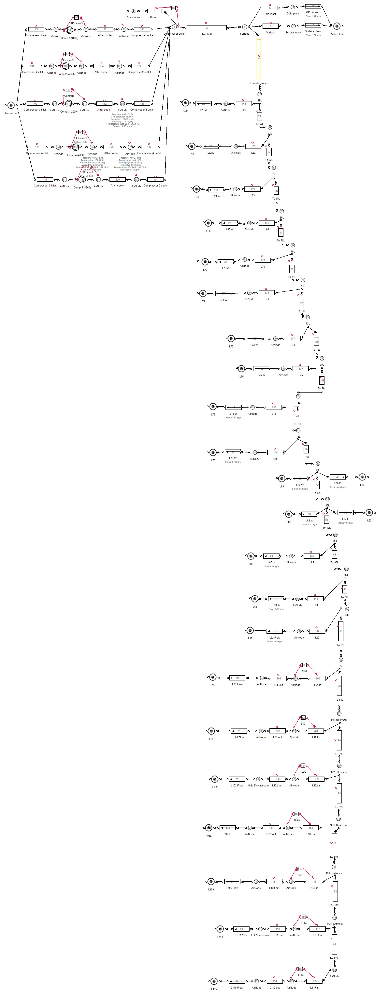

Figure II.2: Mine B: Baseline process Flow diagram.

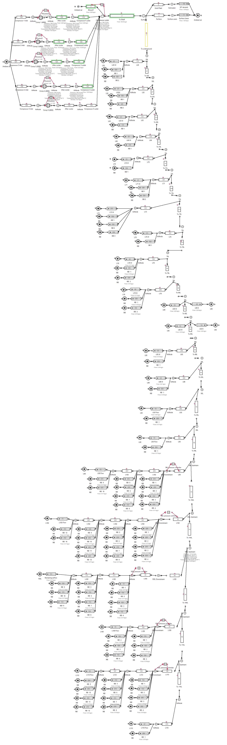

Figure II.3: Mine B: Simulation process Flow diagrams for the refuge bay scenario.

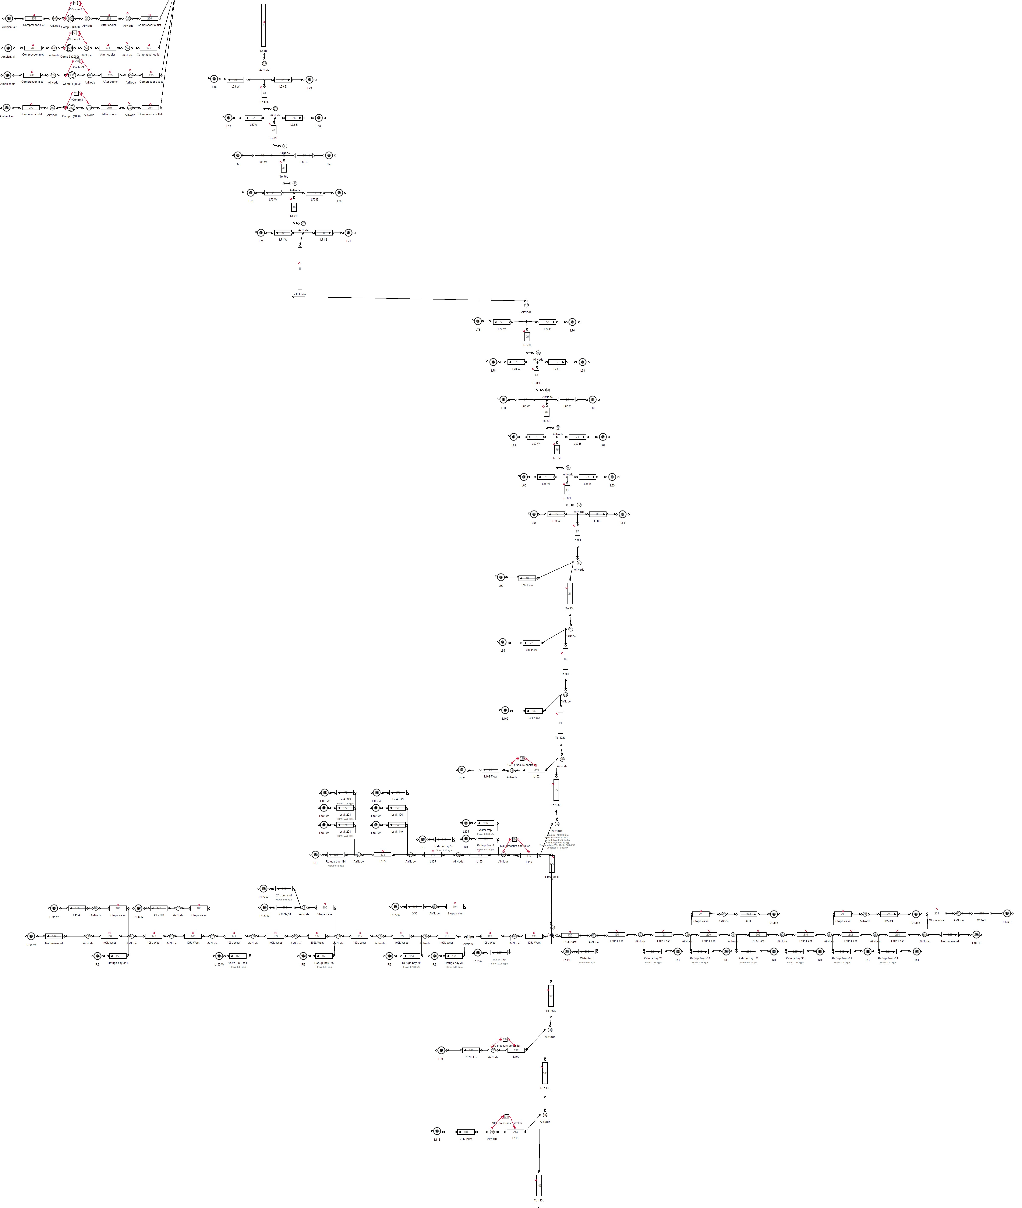

Figure II.4: Mine B: Simulation process Flow diagram for the station isolation stope control.

**APPENDIX III**

## Model component verification tables

Component Actual Ave. Simulated Ave. Accuracy

Power (*kW* )

|  |  |  |  |
| --- | --- | --- | --- |
| VK-32 1 | 0 | 0 | 100% |
| VK-32 2 | 460 | 477 | 96*.*35% |
| VK-32 3 | 142 | 117 | 82*.*31% |
| VK-32 4 | 428 | 408 | 95*.*45% |
| VK-32 5 | 1813 | 1903 | 95*.*03% |
| VK-32 6 | 732 | 725 | 99*.*01% |
| VK-10 1 | 744 | 745 | 90*.*02% |
| VK-10 2 | 687 | 635 | 92*.*24% |
| System | 4940 | 4911 | 97*.*34% |

Flow (*kg/s*)

|  |  |  |  |
| --- | --- | --- | --- |
| 1# 15L | 1*.*45 | 1*.*42 | 97*.*87% |
| 1# 16L | 2*.*15 | 2*.*18 | 98*.*48% |
| 1# 17L | 0*.*34 | 0*.*35 | 97*.*30% |
| 1# 18L | 0*.*38 | 0*.*39 | 97*.*39% |
| 1# 19L | 0*.*31 | 0*.*31 | 98*.*77% |
| 1# 20L | 0*.*12 | 0*.*13 | 92*.*65% |
| 2# 23L | 1*.*31 | 1*.*35 | 96*.*69% |
| 3# 21L | 0*.*67 | 0*.*66 | 98*.*68% |
| 3# 22L | 0*.*74 | 0*.*67 | 89*.*54% |
| 3# 23L | 0*.*04 | 0*.*04 | 98*.*72% |
| 3# 24L | 0*.*11 | 0*.*11 | 98*.*76% |
| 3# 25L | 0*.*33 | 0*.*33 | 99*.*95% |
| 3# 26L | 0*.*45 | 0*.*47 | 95*.*07% |
| Gold Plant | 2*.*59 | 2*.*48 | 95*.*72% |
| Total | 9*.*32 | 9*.*51 | 97*.*01% |

Pressure (*kPa*)

|  |  |  |  |
| --- | --- | --- | --- |
| 1# 15L | 394 | 384 | 98*.*55% |
| 1# 16L | 421 | 419 | 99*.*61% |
| 1# 17L | 345 | 344 | 99*.*81% |
| 1# 18L | 336 | 336 | 99*.*99% |
| 1# 19L | 311 | 309 | 99*.*53% |
| 1# 20L | 368 | 368 | 99*.*90% |
| 2# 23L | 365 | 327 | 91*.*25% |
| 3# 21L | 303 | 302 | 99*.*92% |
| 3# 22L | 332 | 301 | 95*.*42% |
| 3# 23L | 332 | 332 | 99*.*98% |
| 3# 24L | 413 | 409 | 99*.*10% |
| 3# 25L | 413 | 409 | 99*.*01% |
| 3# 26L | 515 | 509 | 98*.*99% |
| Surface | 502 | 501 | 99*.*95% |

Table III.1: Case study A: Model verification

Component Actual Ave. Simulated Ave. Accuracy

Power (*kW* )

|  |  |  |  |
| --- | --- | --- | --- |
| Compressor 1 | 3406 | 3669 | 92*.*37% |
| Compressor 2 | 3911 | 3668 | 93*.*92% |
| Compressor 3 | 1440 | 1453 | 99*.*05% |
| Compressor 4 | 0 | 0 | 100% |
| Compressor 5 | 3299 | 3274 | 99*.*22% |
| System | 12057 | 12103 | 98*.*73% |

Flow (*kg/s*)

|  |  |  |  |
| --- | --- | --- | --- |
| 95L | 1*.*51 | 1*.*42 | 93*.*95% |
| 98L | 3*.*75 | 3*.*53 | 93*.*99% |
| 102L | 2*.*97 | 2*.*79 | 98*.*72% |
| 105L | 5*.*65 | 5*.*71 | 98*.*84% |
| 109L | 3*.*57 | 3*.*37 | 94*.*27% |
| 113L | 5*.*09 | 4*.*84 | 95*.*05% |
| Gold Plant | 1*.*41 | 1*.*35 | 95*.*14% |
| Sub-shaft total | 34*.*12 | 34*.*76 | 98*.*09% |
| Total | 41*.*65 | 41*.*43 | 98*.*96% |

Pressure (*kPa*)

Surface 393 396 99*.*02%

Table III.2: Case study B: Model verification